TASK-1

**SALESFORCE SAPI – with MUnits**

**Use Case:**  
There is a team who wants to consume a custom object in Salesforce called Organization which has attributes of (Organization Name, Address, City, State, Zip, Phone number, revenue).Task:

* Inside Salesforce
* Create a custom object with provided attributes
* Once done, add the custom object to your Sales Tab
* Inside Mulesoft
* Create a Salesforce System API which returns the custom object (Organization) data inside salesforce. (Please follow the API Led Lifecycle)
* Create an endpoint called health check, which performs a connectivity test with Salesforce.
* Write MUnits for health check and retrieval of custom objects

**Task 1 Continued:**

* Create and maintain a Mule EE Local Runtime
* Register with Anypoint Platform
* Create Domain Project
* Deploy Domain Project in Local Runtime
* Deploy the SAPI to Mule EE Runtime
* Apply Client Credentials as part of Anypoint Platform
* Postman Collection
* Push Logs to Splunk (Optional)

STEP1:

**To create a custom Object in Salesforce:**

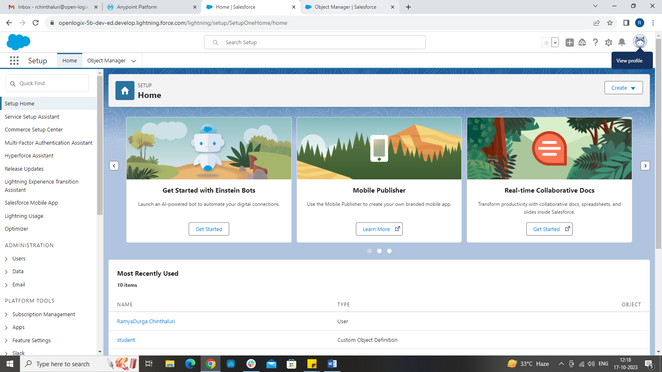

Go to setup -> object Manager -> create a custom object

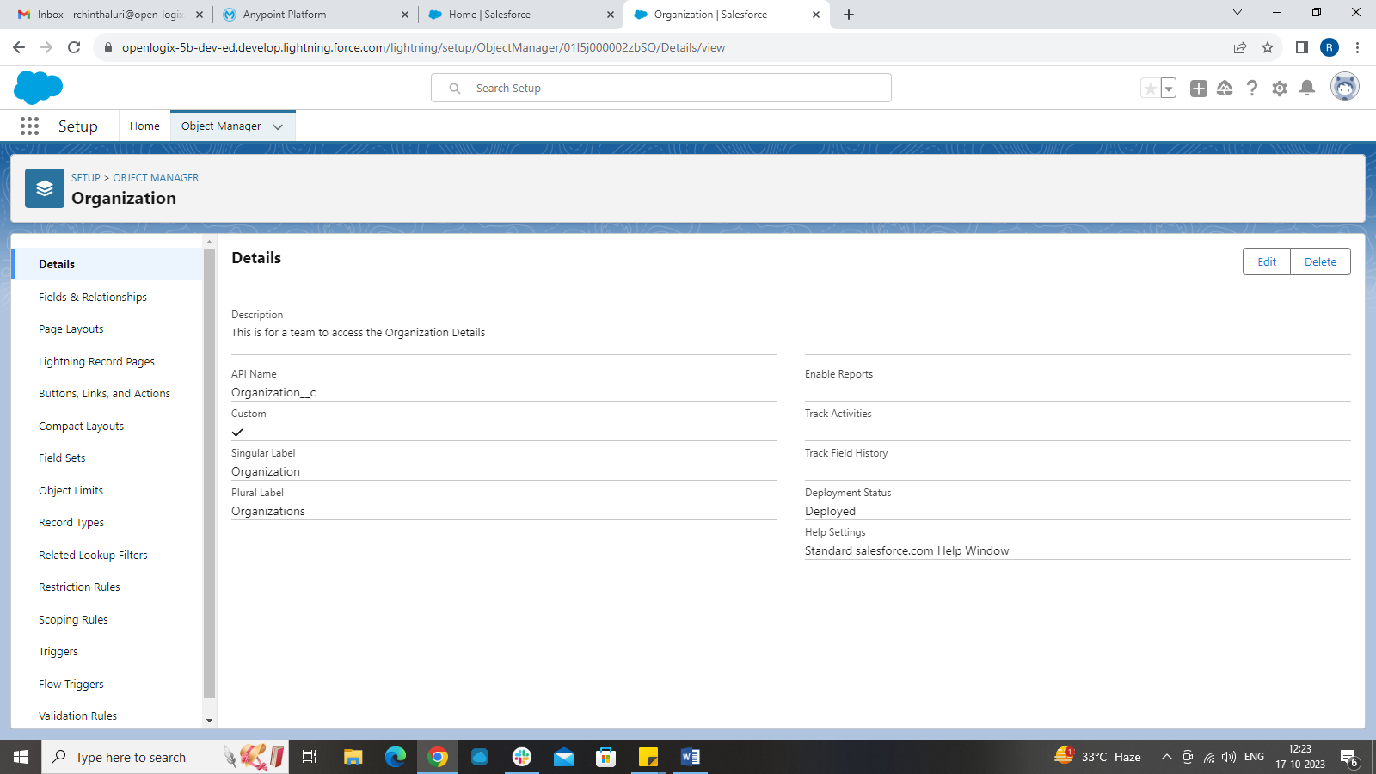

Custom object created and we can add the required fields using fields and relationships tab.

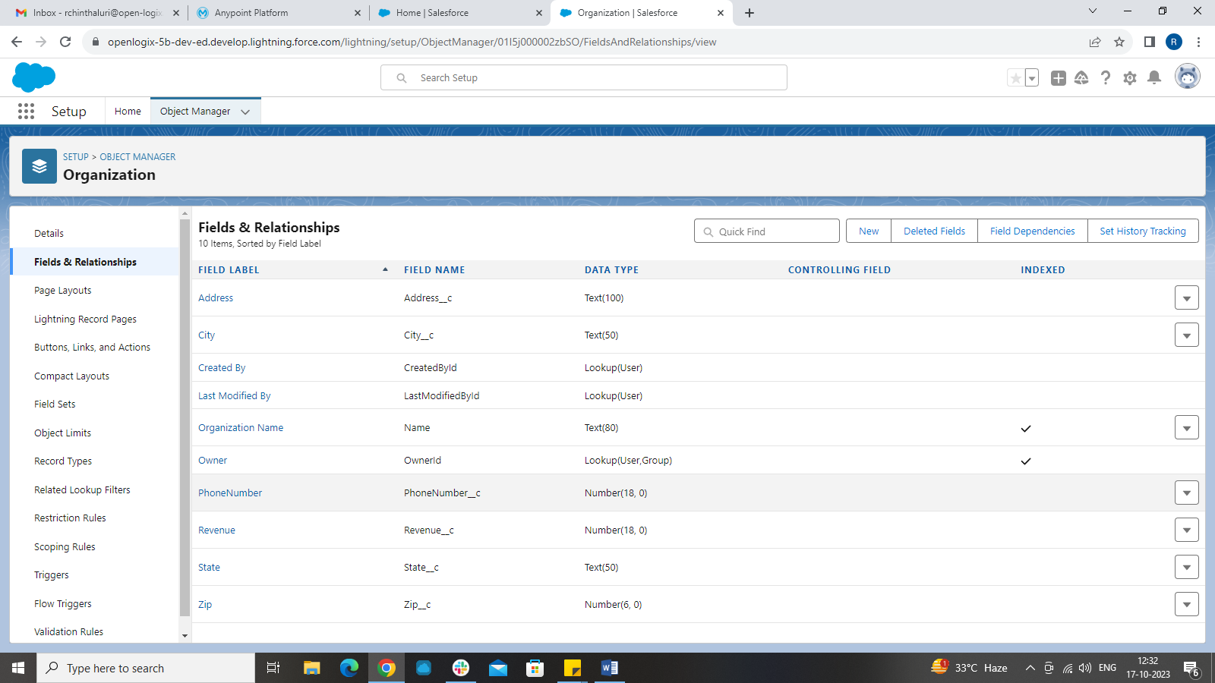

**STEP2:**

**Adding the Salesforce Custom object to tabs:**

We need to click on apps and search for sales .  
Go to the right hand corner and edit the setup to bring your custom object to the position just beside home.  
You can now directly access your custom object in sales tab.

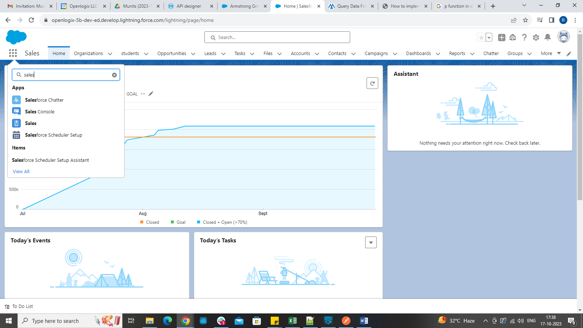

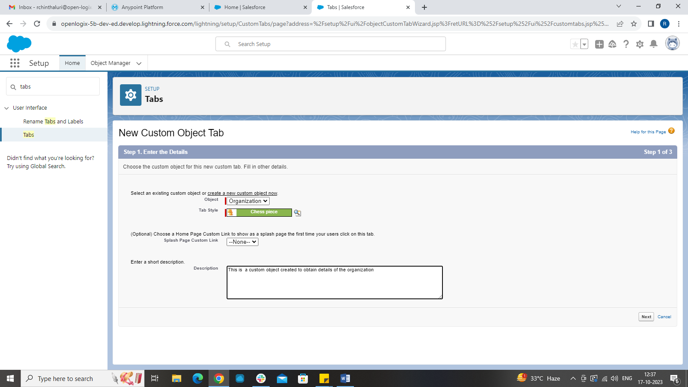

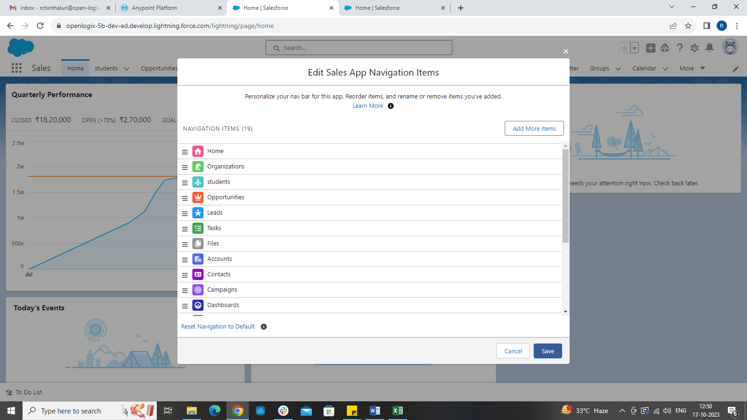

**Using Data Import Wizard to load data of 200 records:**

We can use data import wizard to add the required data to the custom object just by dragging and dropping the csv file containing data.

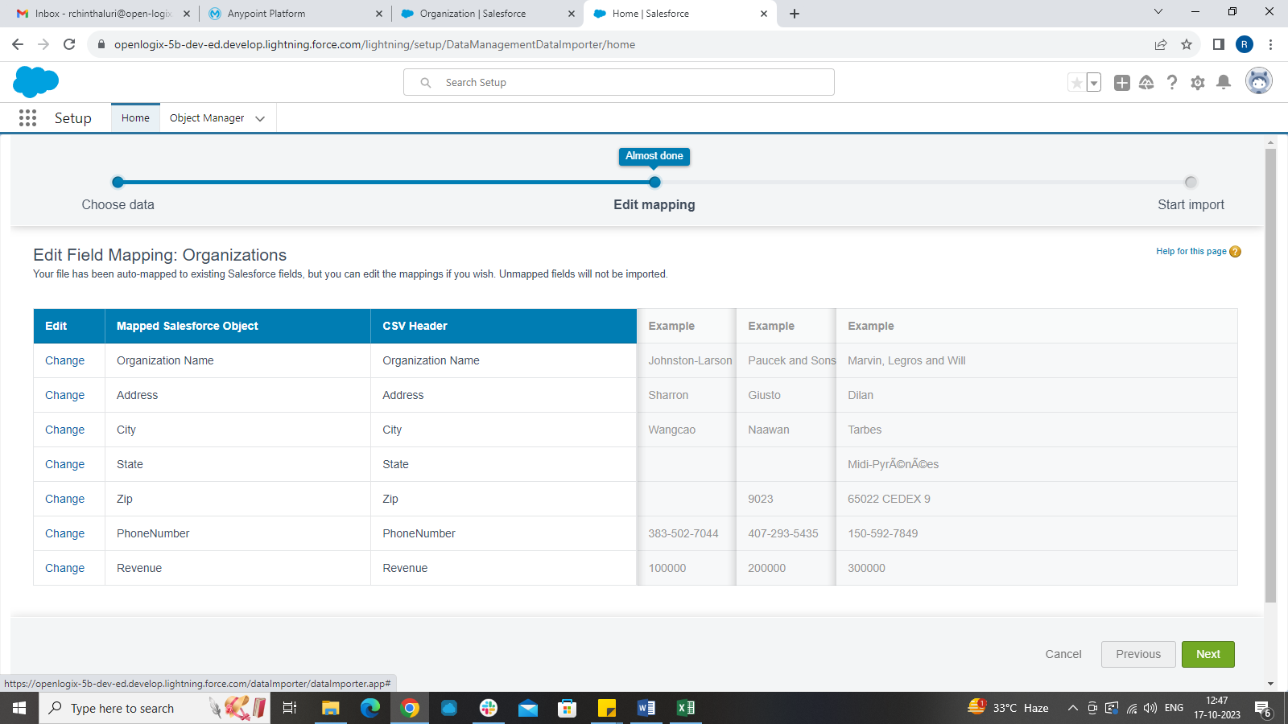

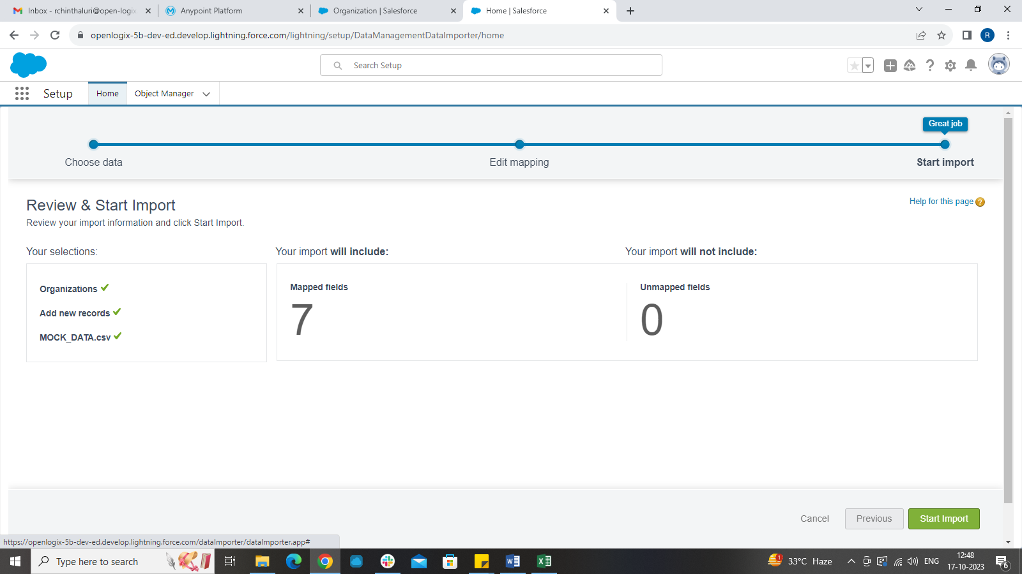

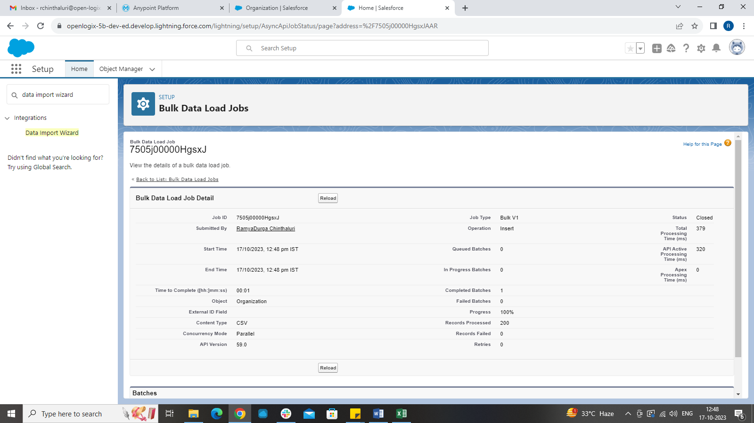

**Data reflected in SF custom object:**

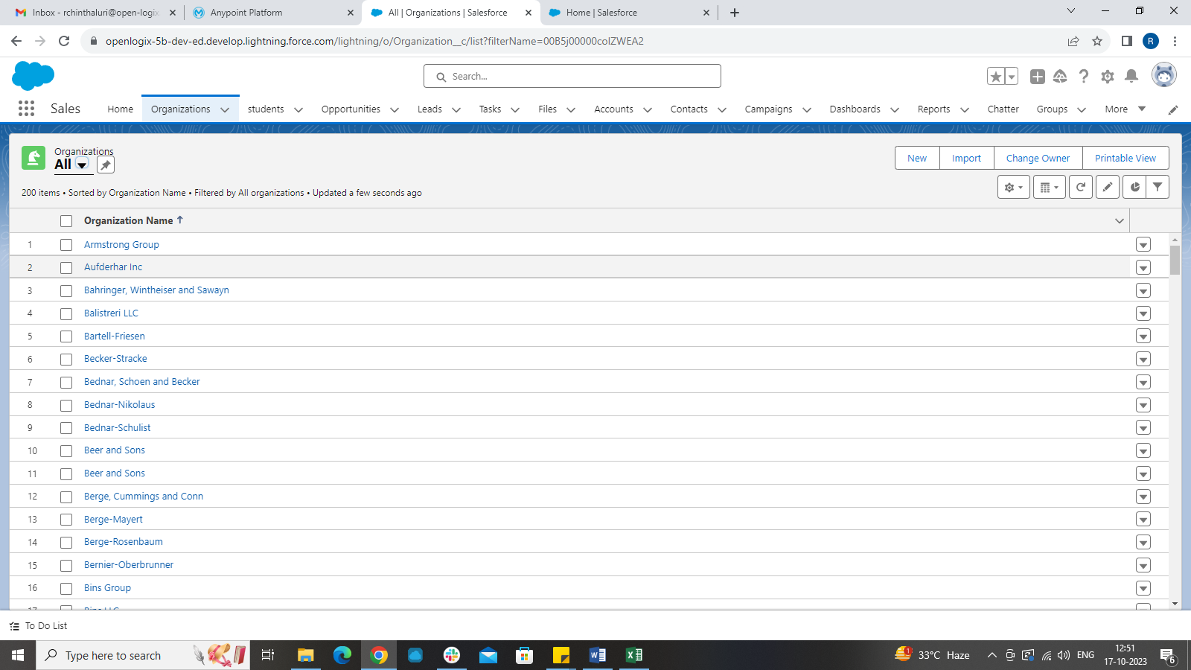

STEP 3:

DESINING API SPECIFICATION (RAML):

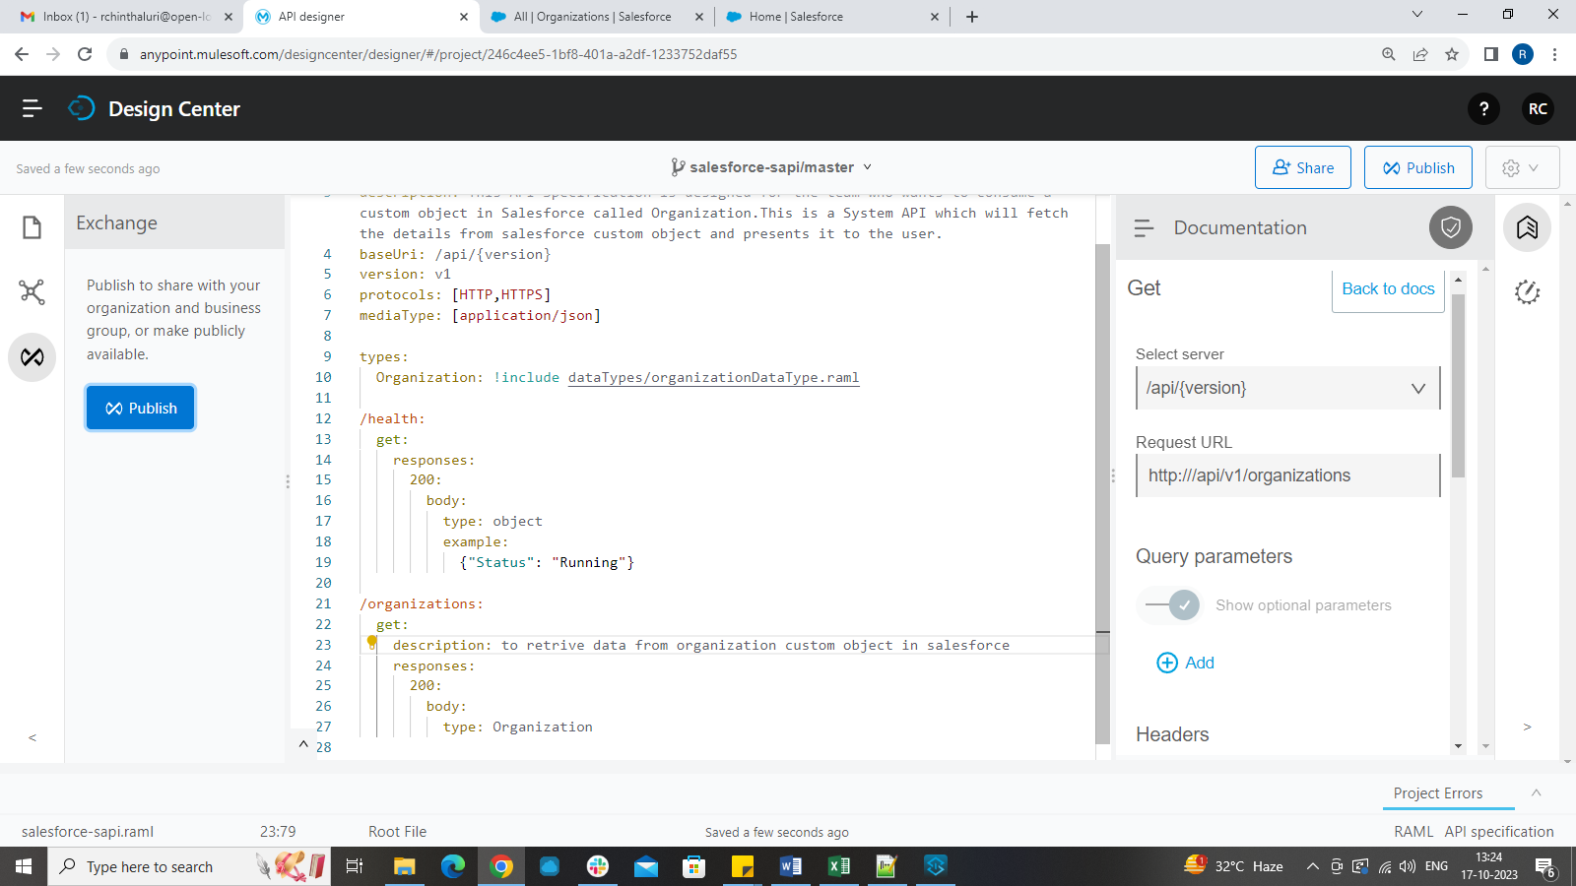

**Publishing to Exchange:**

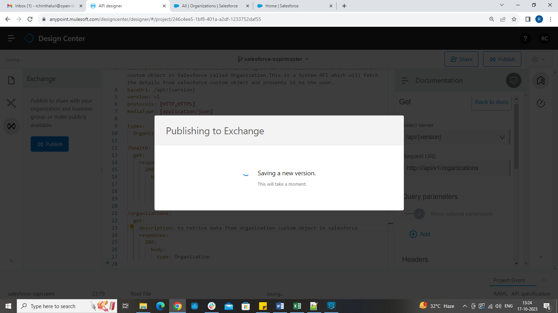

STEP 4:

**Scaffolding in Anypoint Studio:**

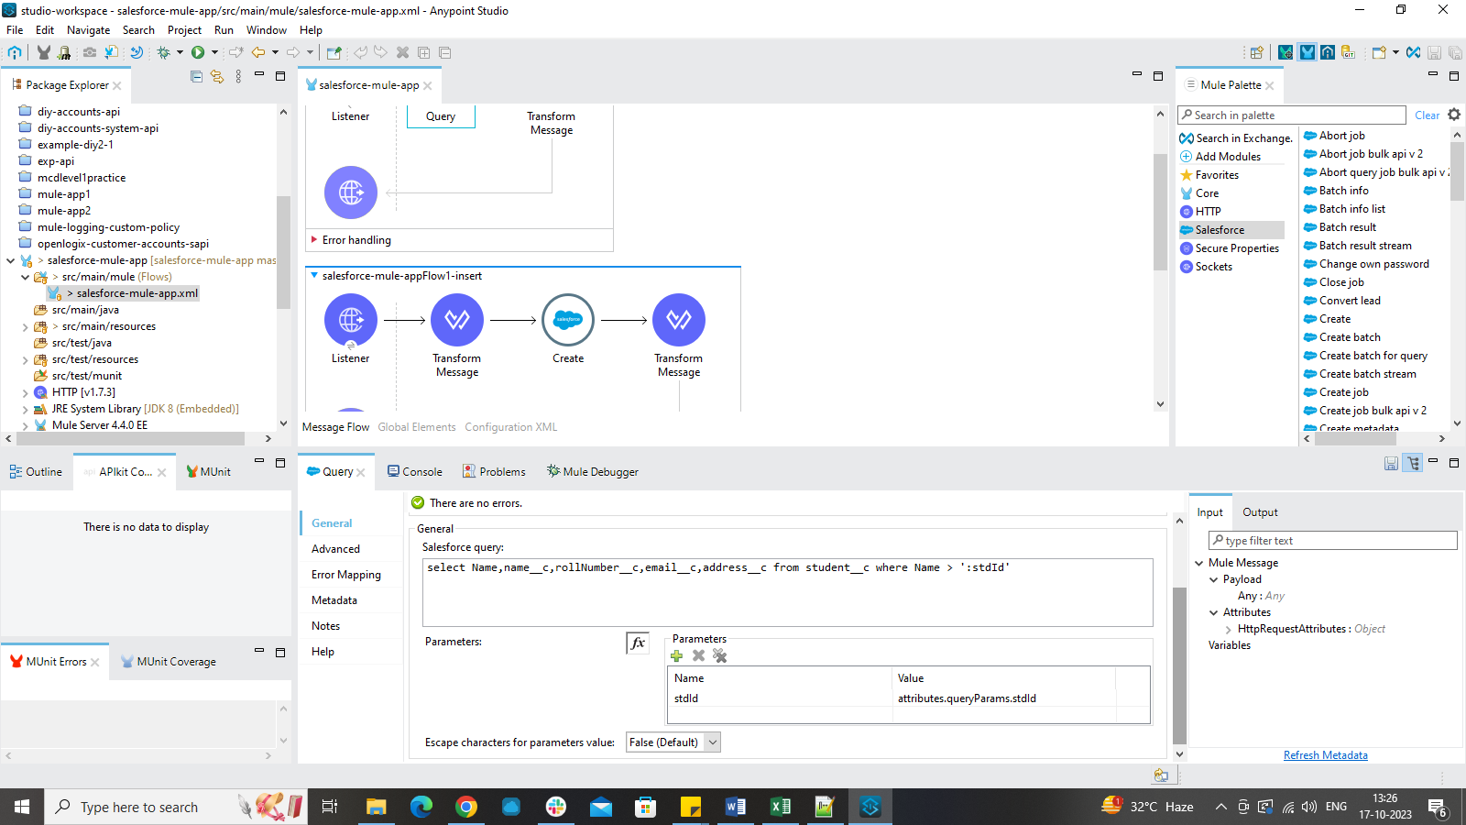

**Anypoint studio salesforce setup:**

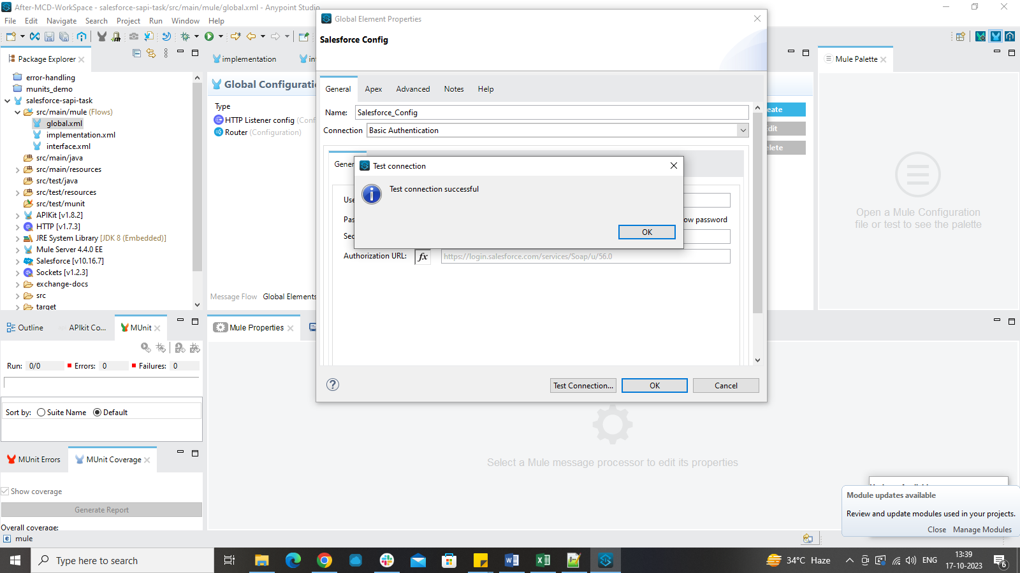

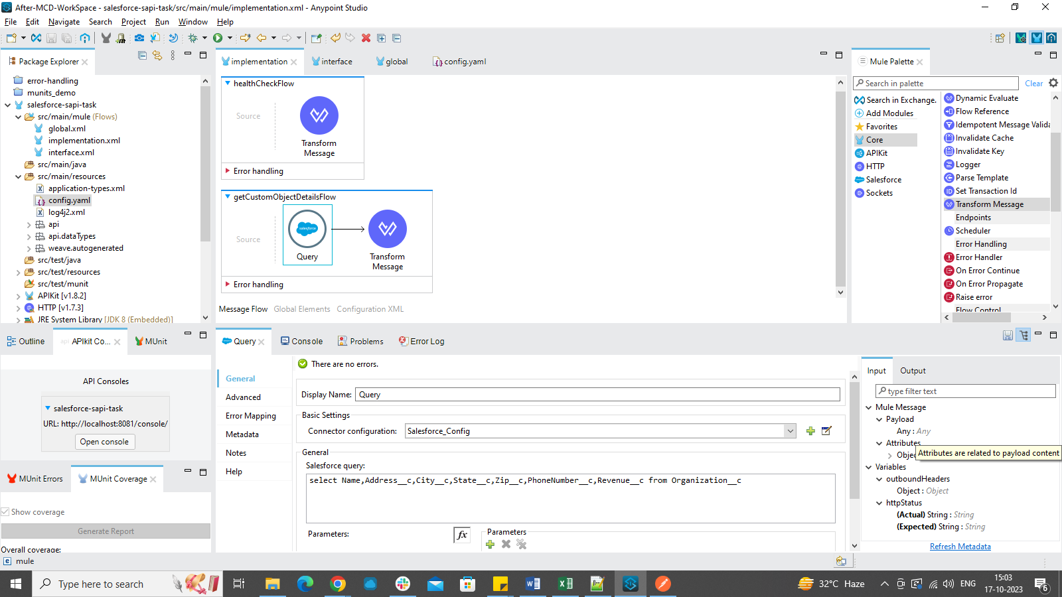

**Checking Query execution in Developer console:**

When we go to developer console in salesforce and execute the query, if the correct records are fetched then we can use same query in our Anypoint studio to do implementation for fetching records from custom object.

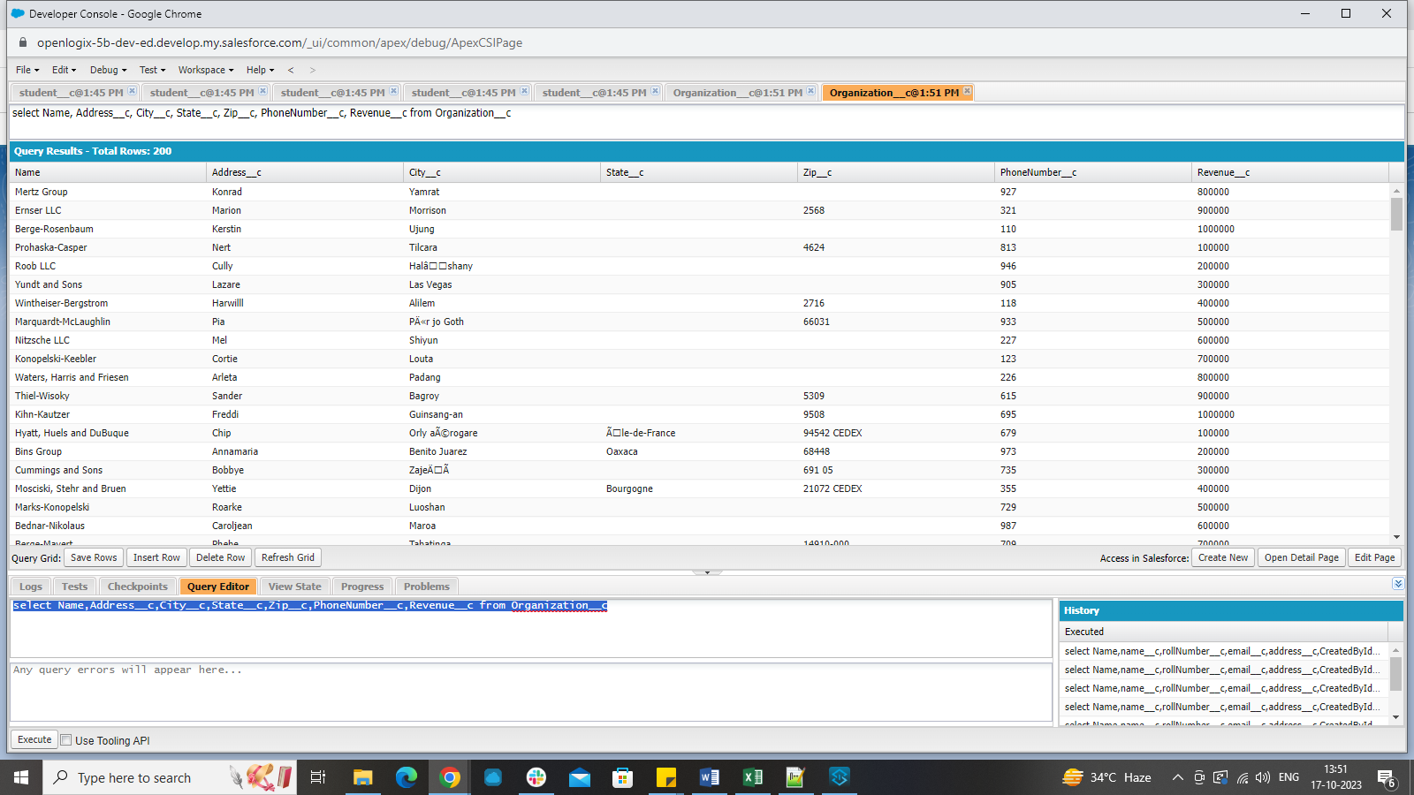

**Output in Postman:**

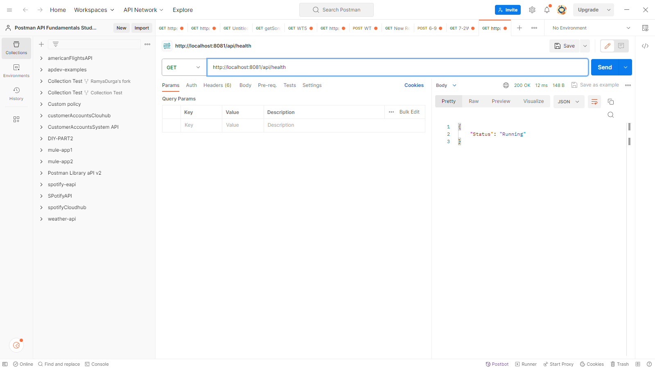

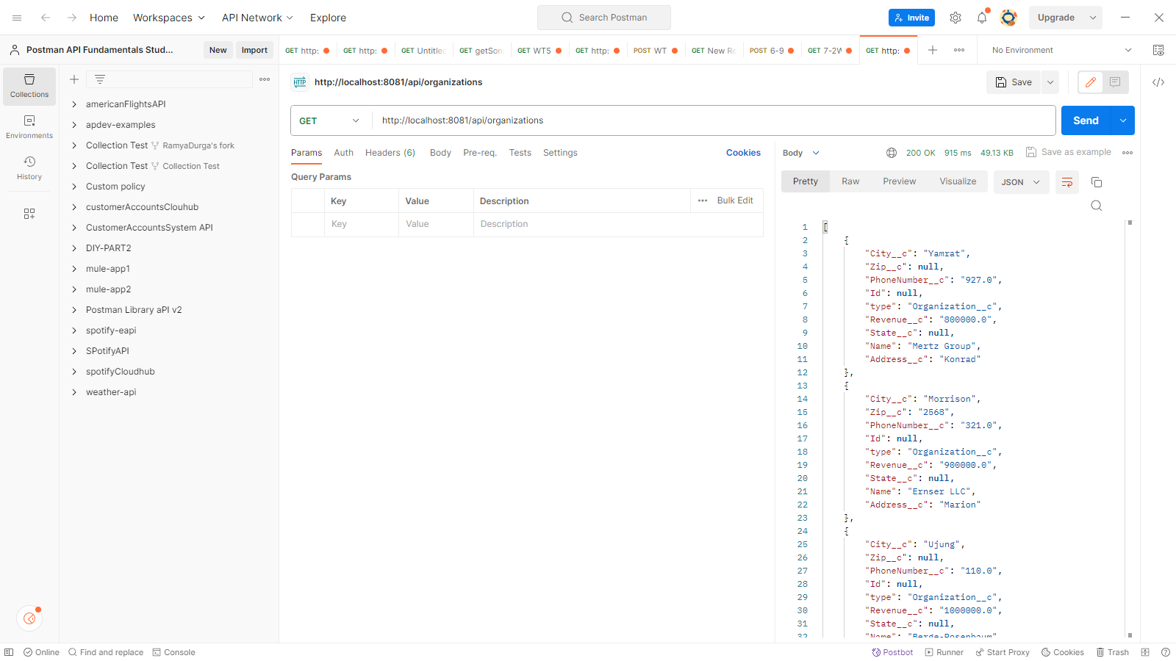

MODIFYING the output through dataweave for matching the output of API specification:

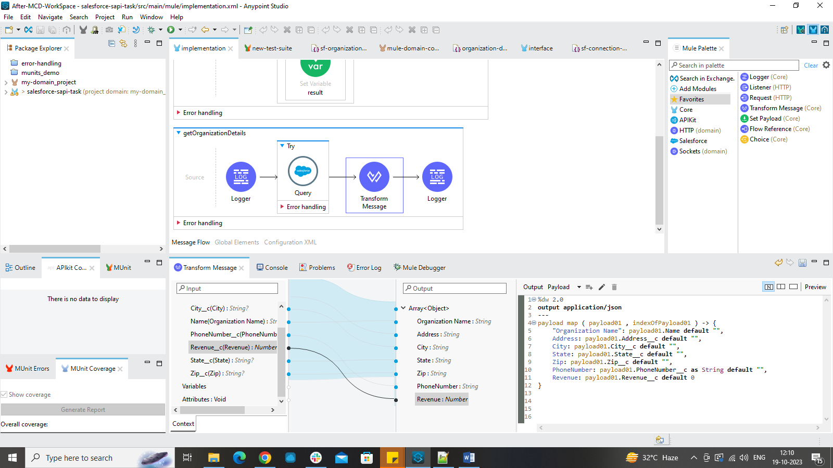

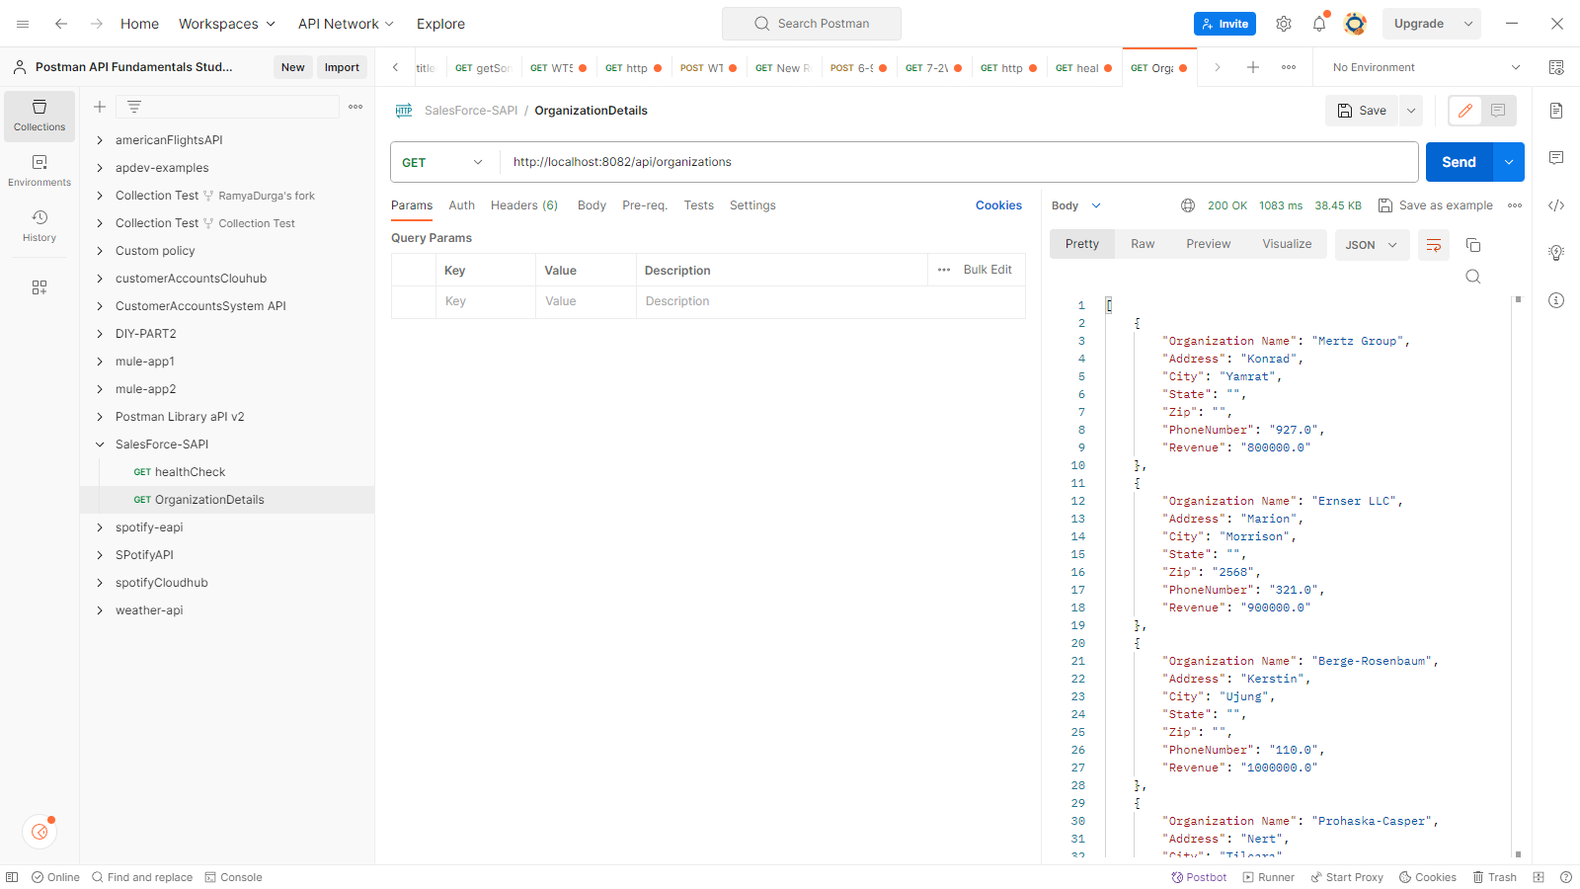

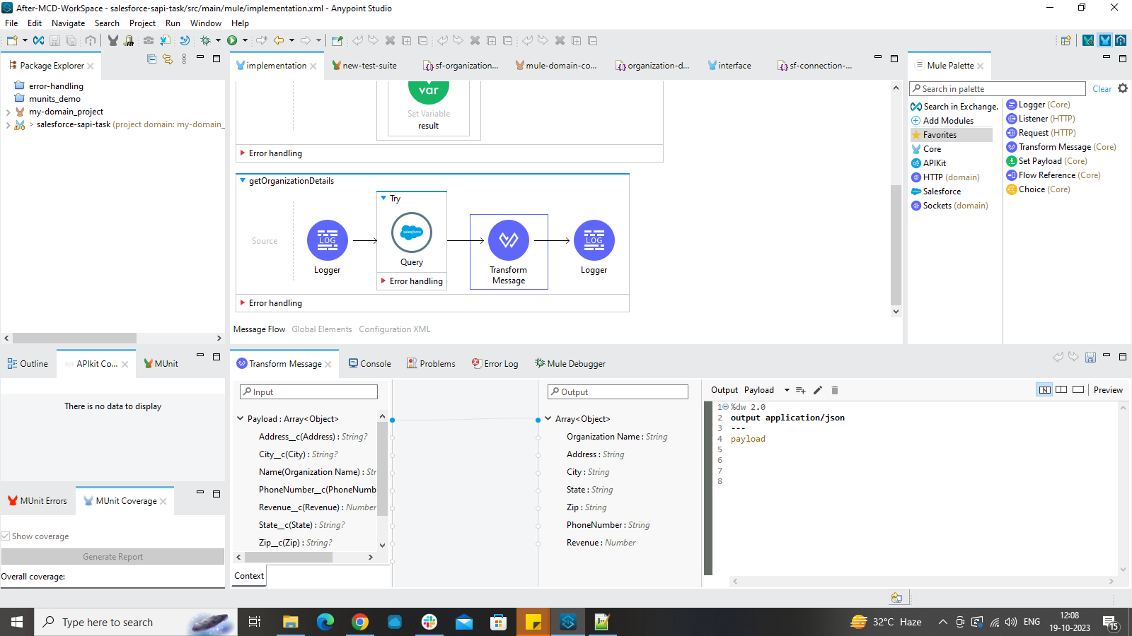

**STEP-5:**

**MUnits:**

Munits is a mule application testing framework which will help us to build automated test cases for our API implementations and integrations. Anypoint Studio is completely integrated with Munits test suite and tools which can be used so that developers can design, create and run unit test cases.

**For health endpoint:**

We will create a yaml file for writing our test cases scenario. We have two options where the salesforce connection should return running or not running.  
If it is connected, it should return running or else it should return not-running.

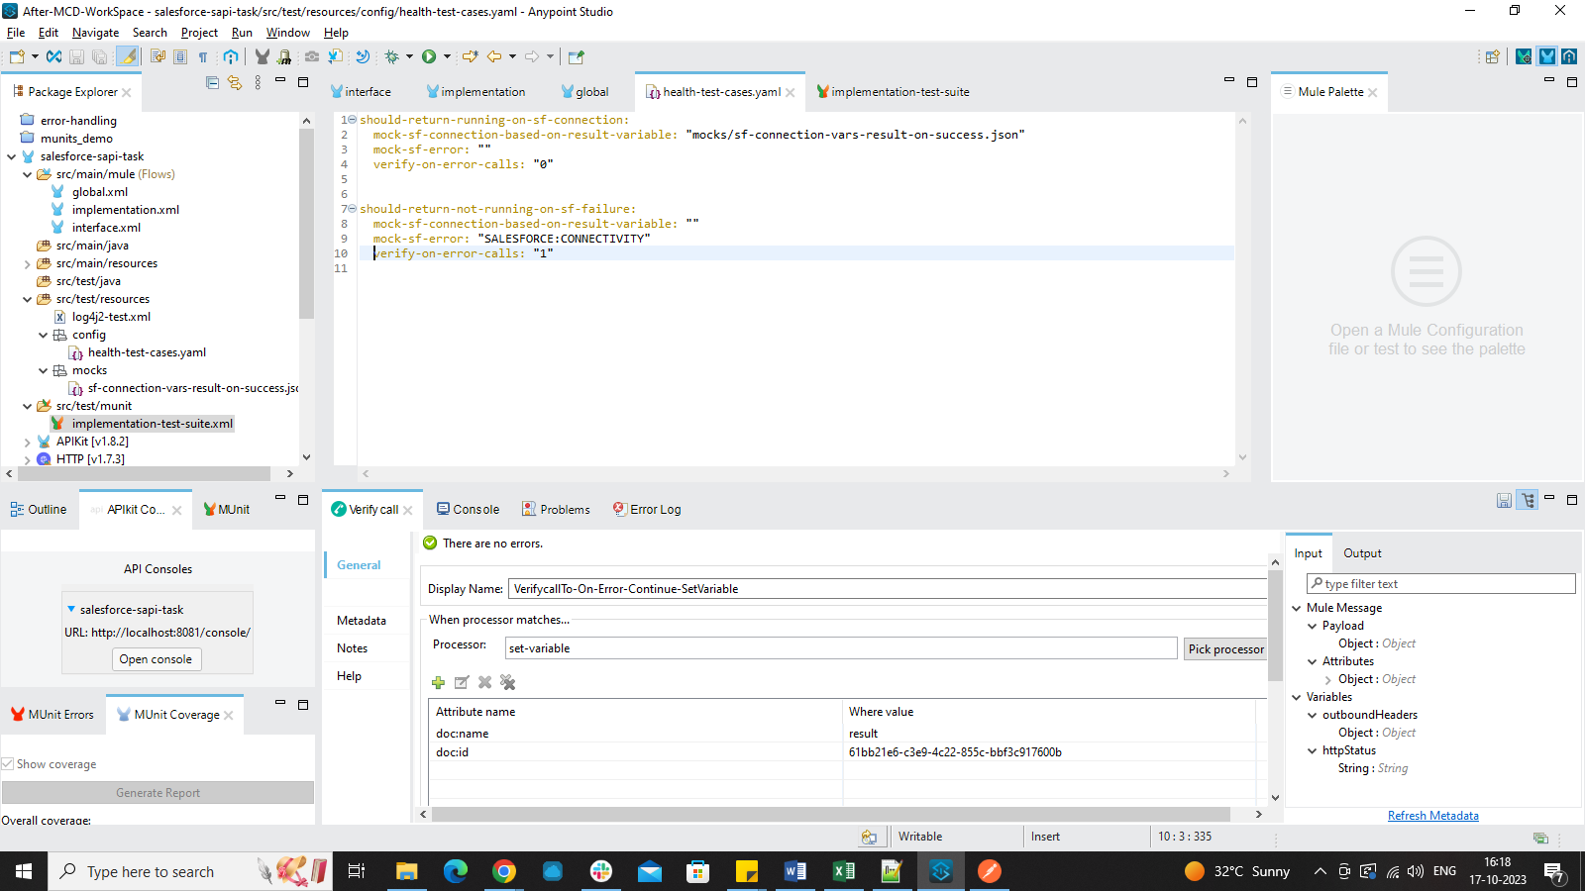

In Munits test suite, we will add the yaml file as parameterization file so that it can check the files and get the required values from there.

We will be using p function to pass the values from this file to the test suite.

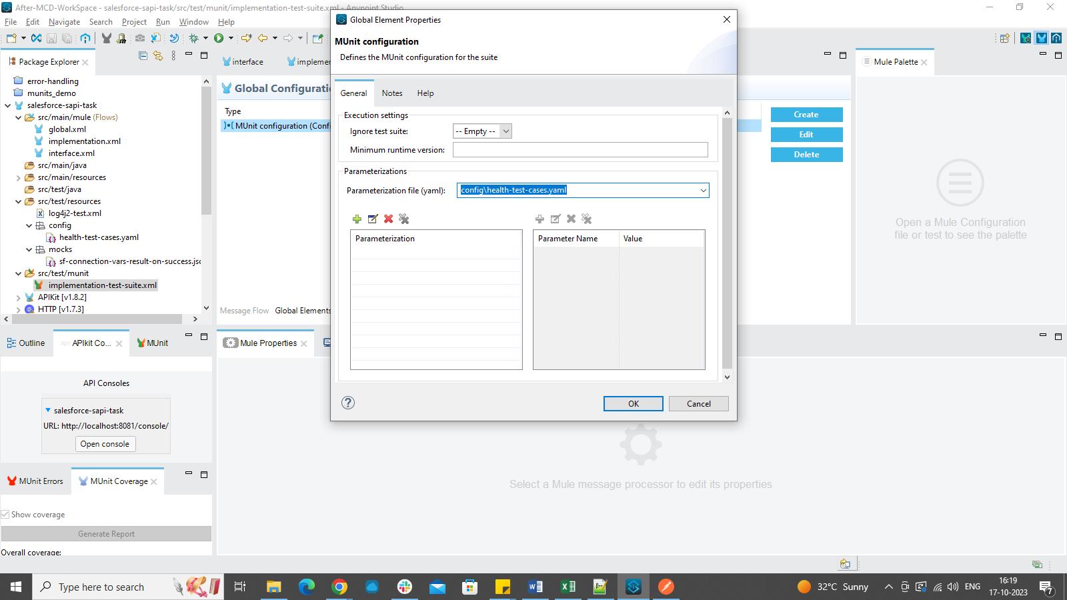

Mock when connector is used to check if the connection is happening without the real connection happening out. You need to select which component should be checked for Mock when and enable its doc-id and doc-name in the pick processor section.

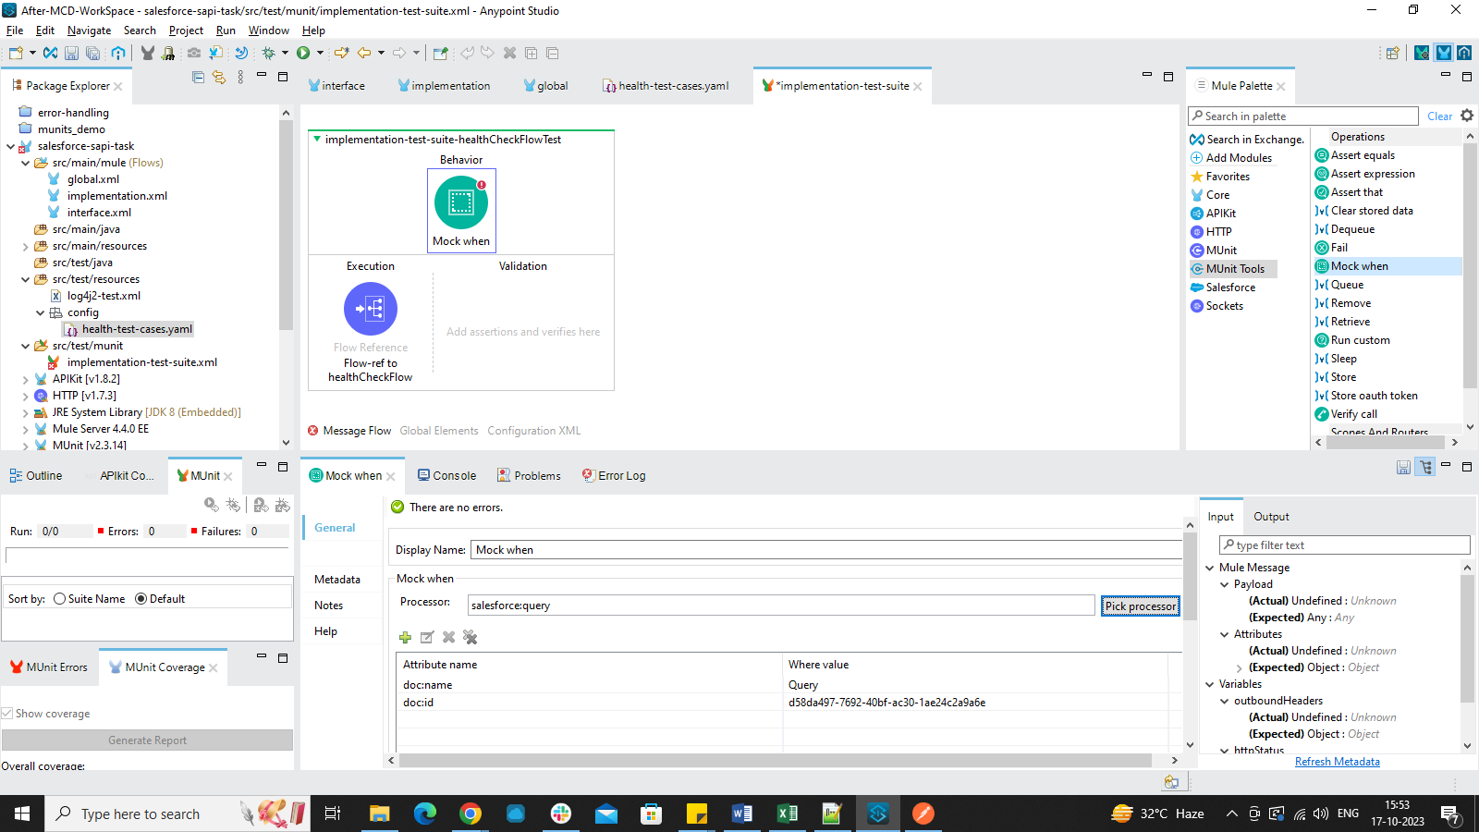

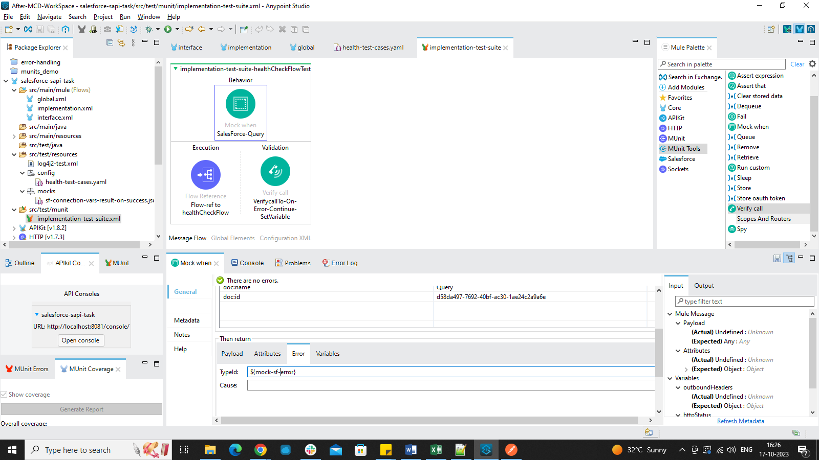

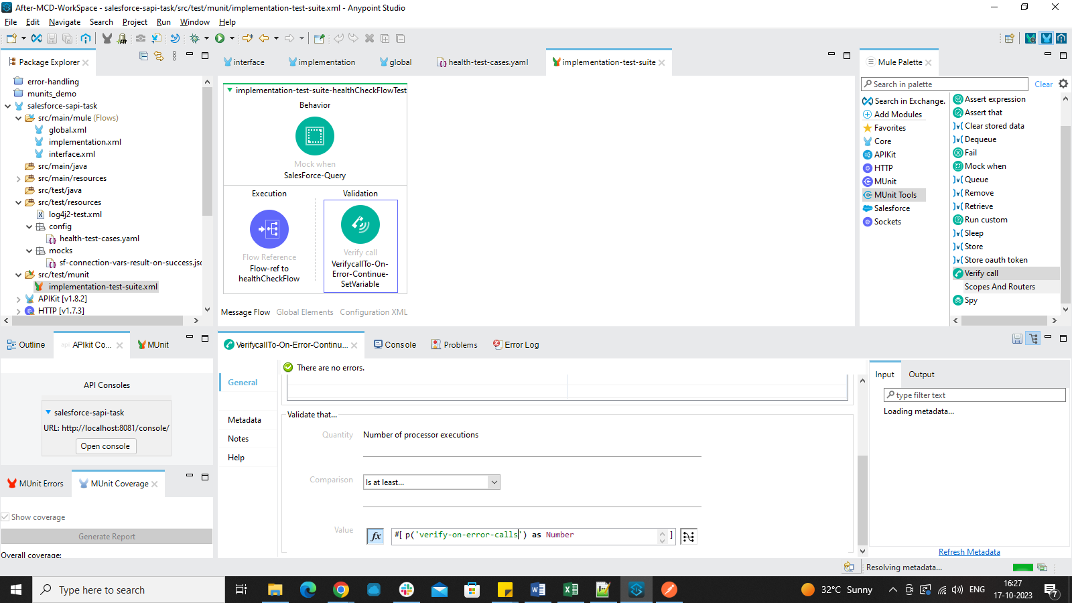

After all the changes are done, we will right click and select Run MUnit test suite option.  
It will return the success or failure test cases at the left hand side and will show the coverage report also.

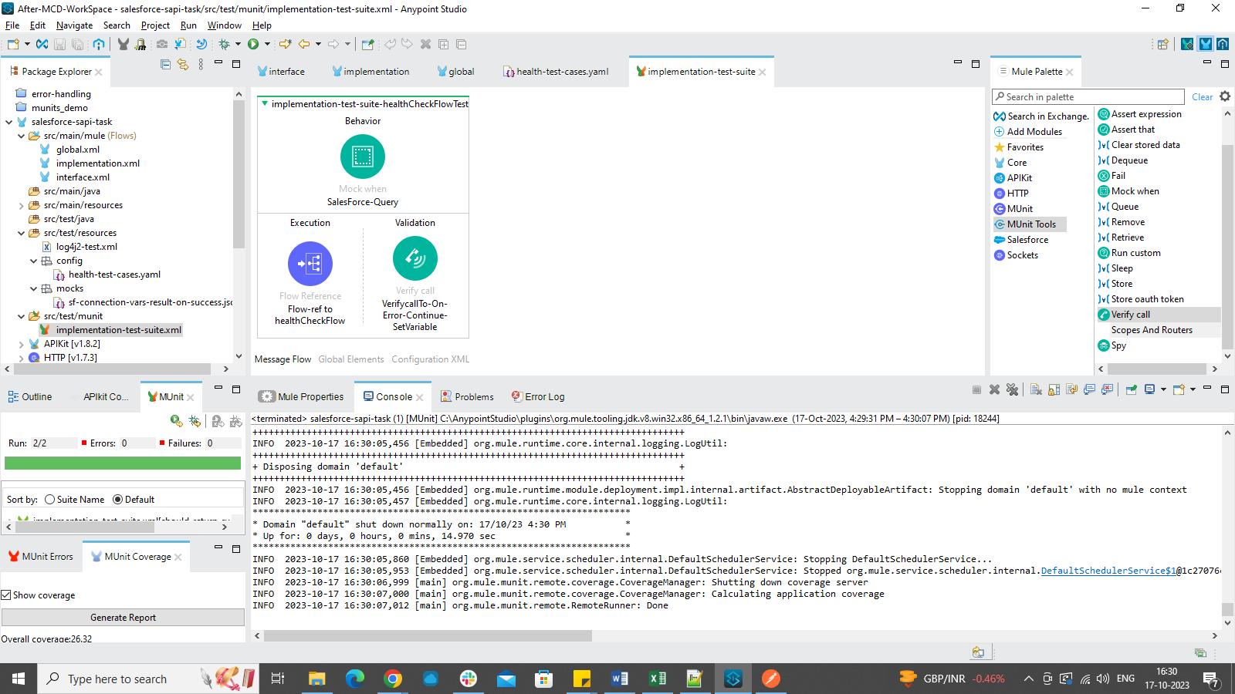

It will also reflect how many components in your implementation got covered by your test cases. If the component is covered, It is indicated with green tick mark over the component.

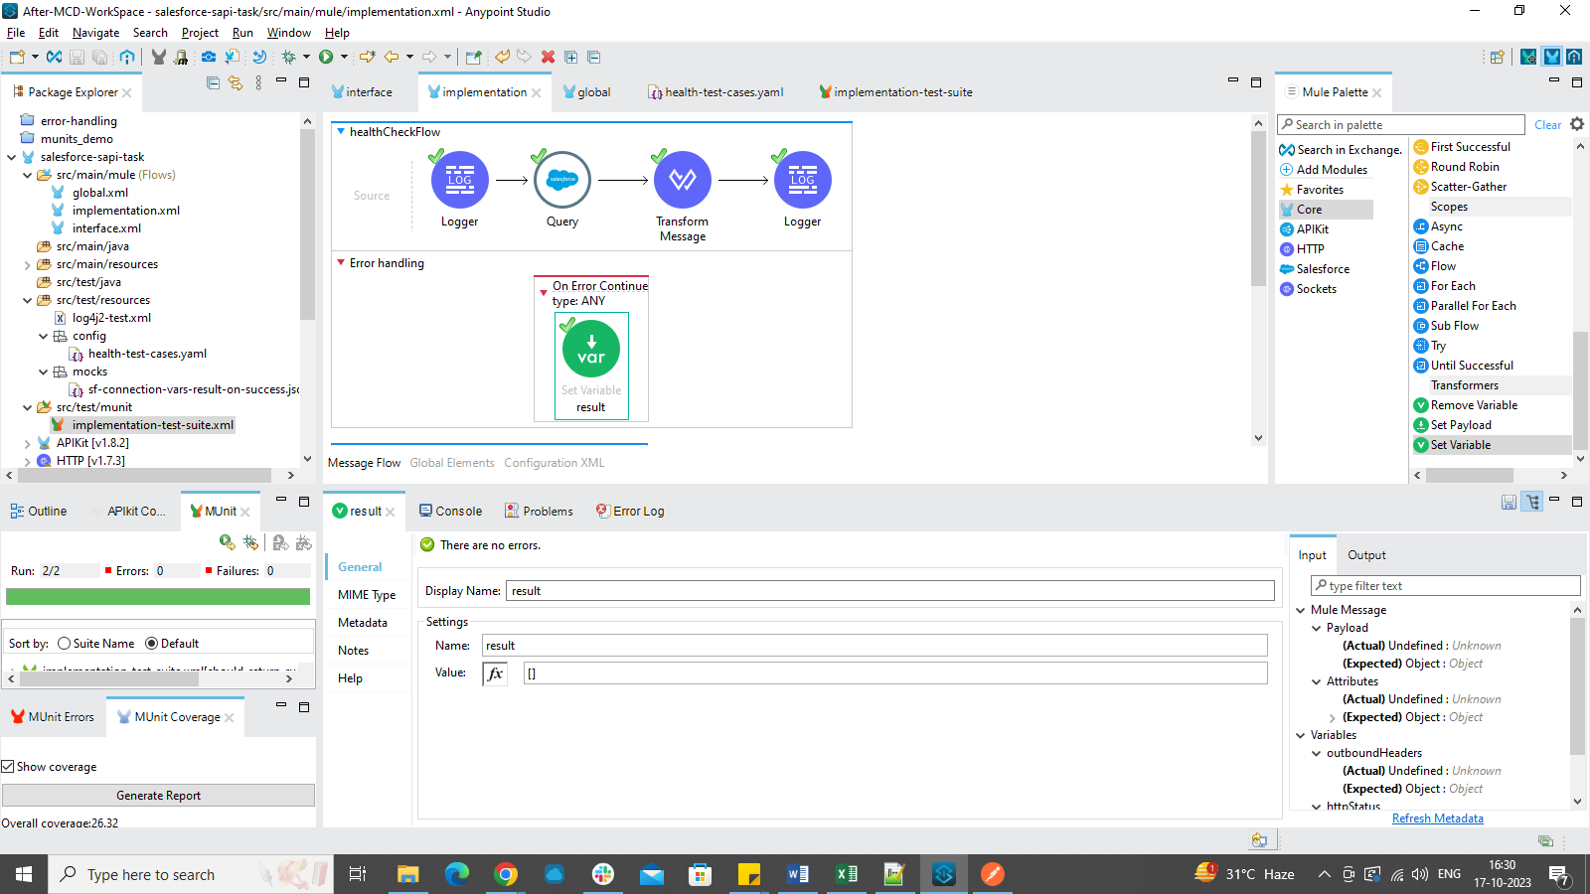

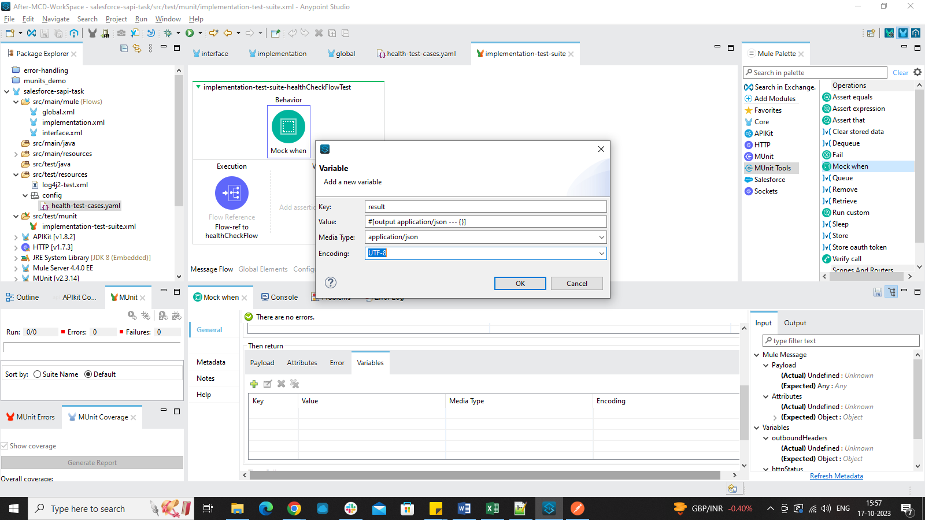

**Assert-equals:**

**Error:**

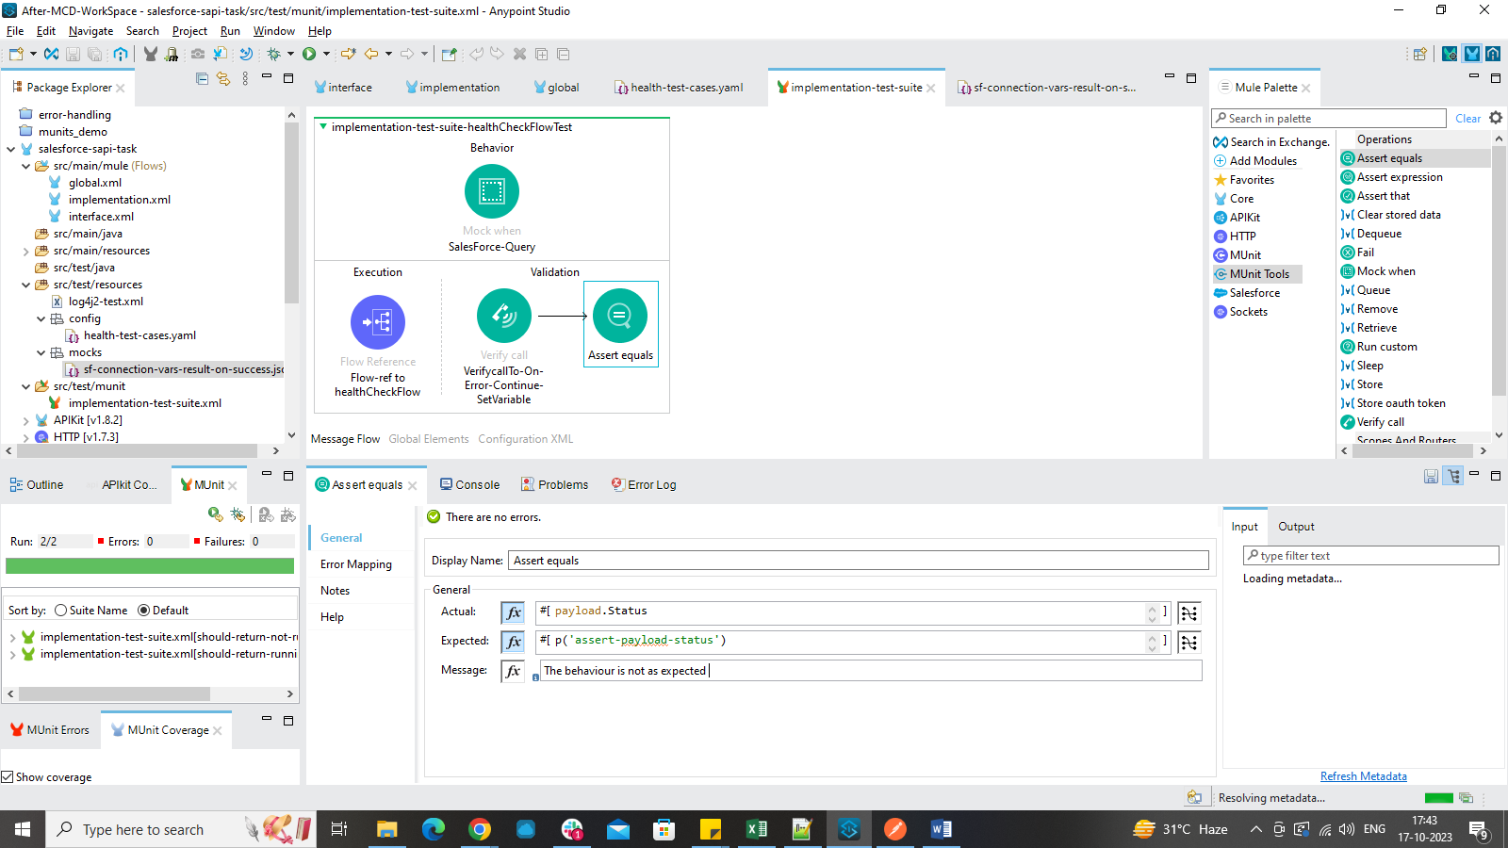

Test cases are failing.

Error message is as below:

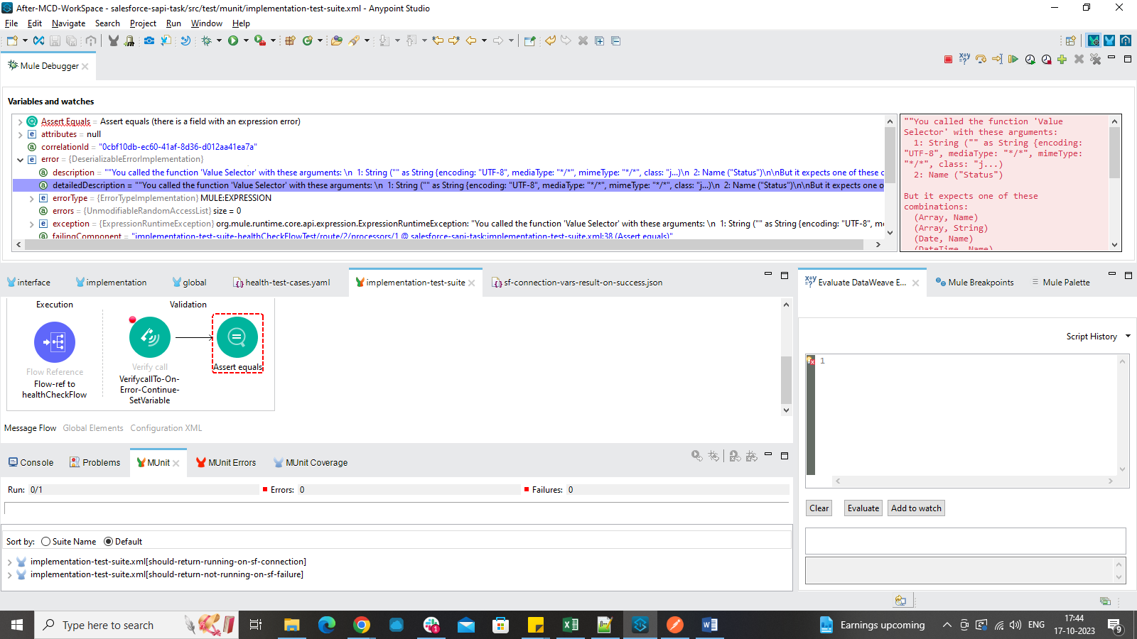

Solution:

Munits to Organization Details Flow:

For Writing Munits to the other flow you cannot pass two parameterization files in one global element.

So we need to create a new test suite by going to src/test/munit folder.

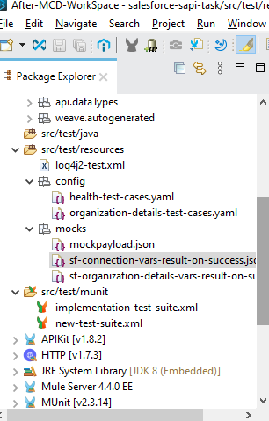

We will mock the Query connector in the flow as it is connecting to external system.

The flow reference in execution section is pointing to the organization Details Flow.

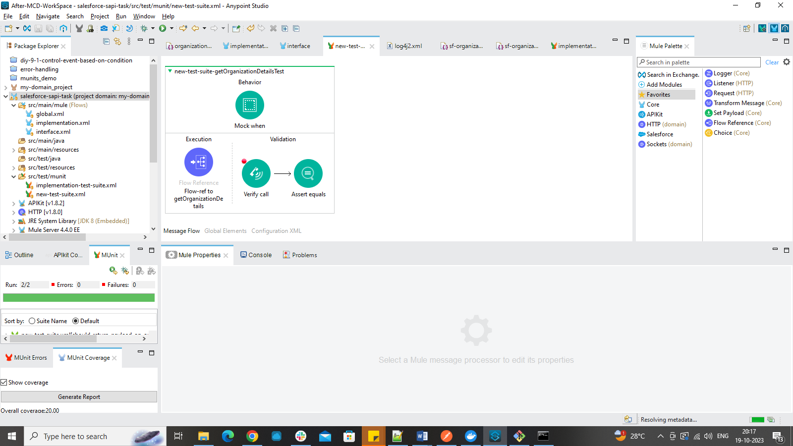

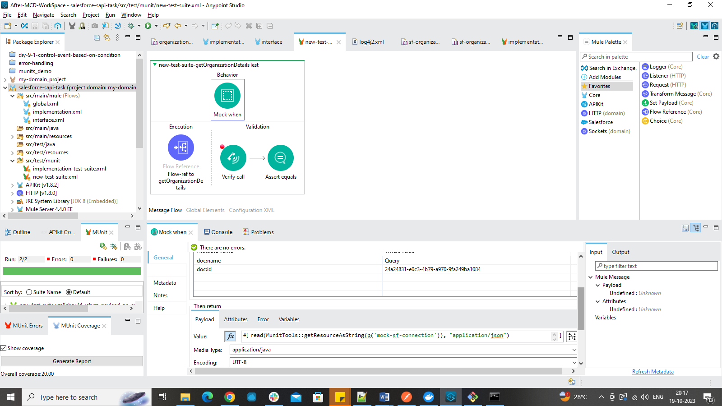

Verify call:

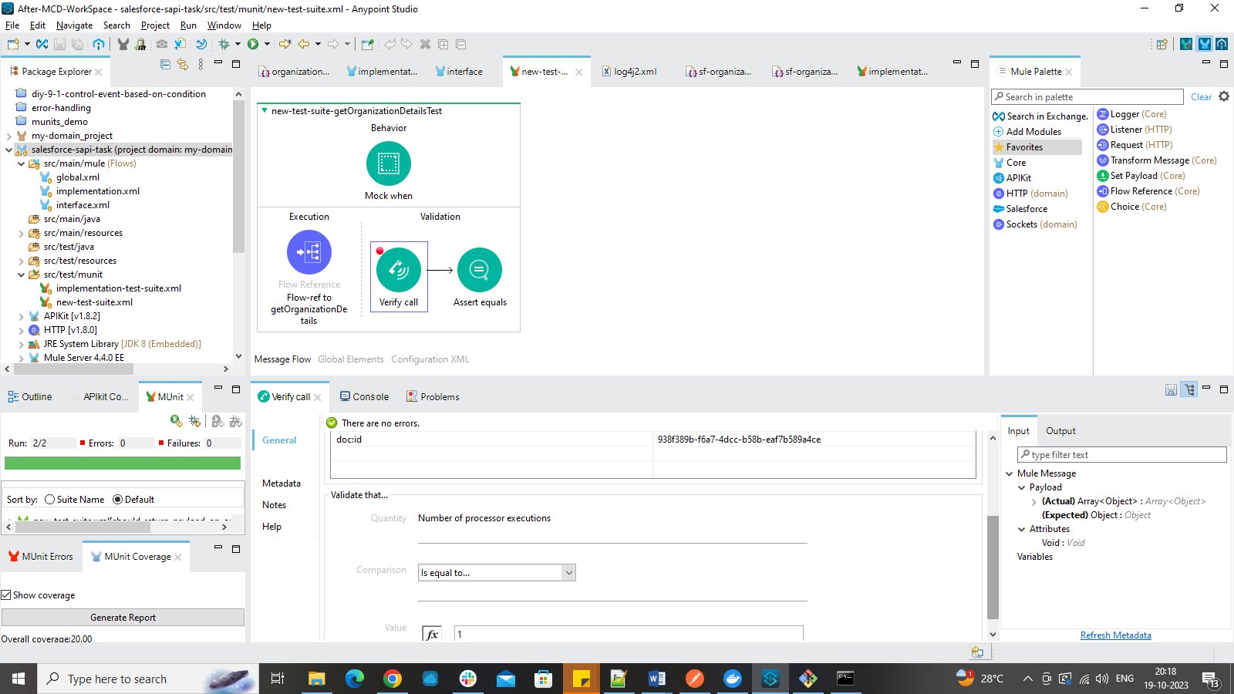

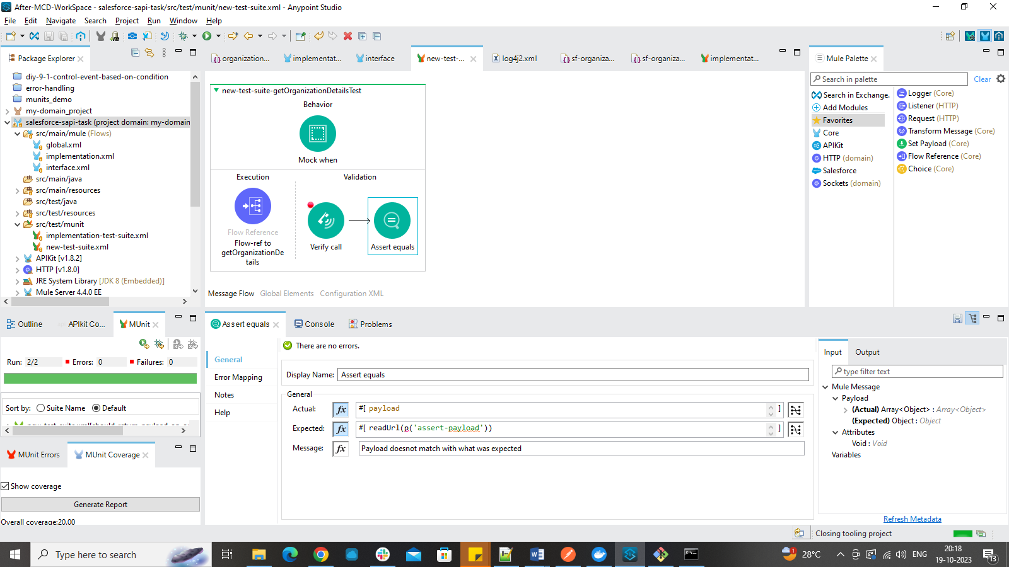

We will write a test-cases. yaml file which will be added to the global element in new test suite as parameterization file.

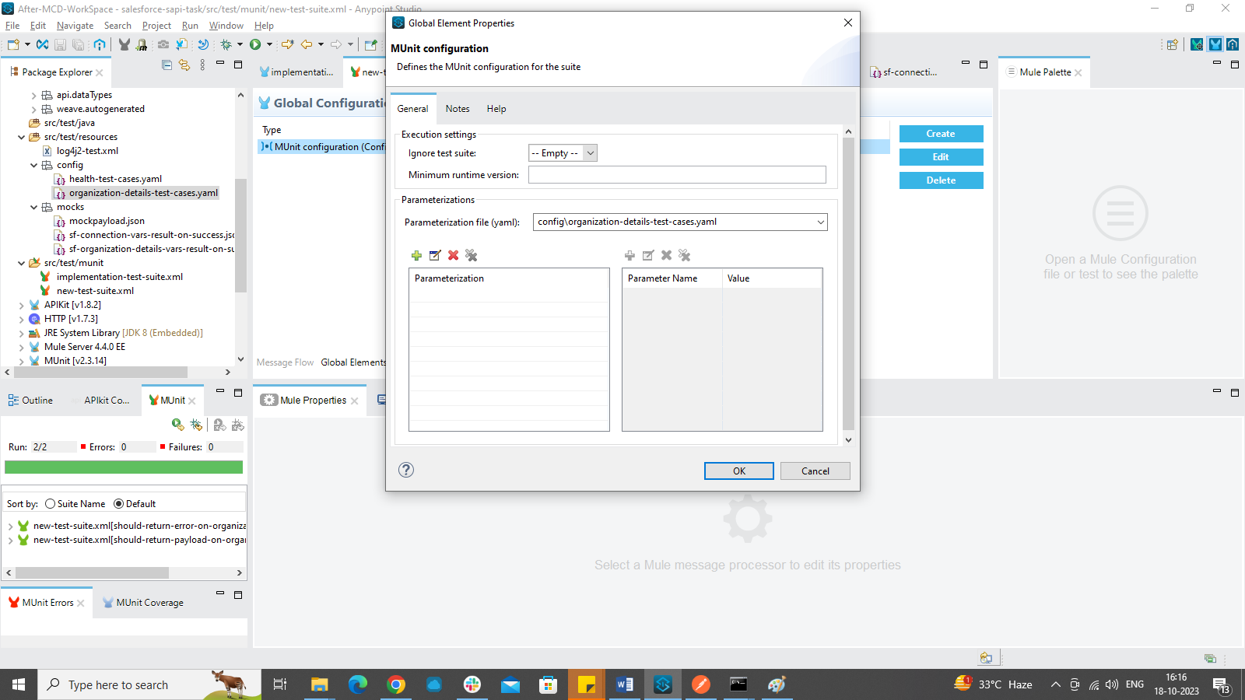

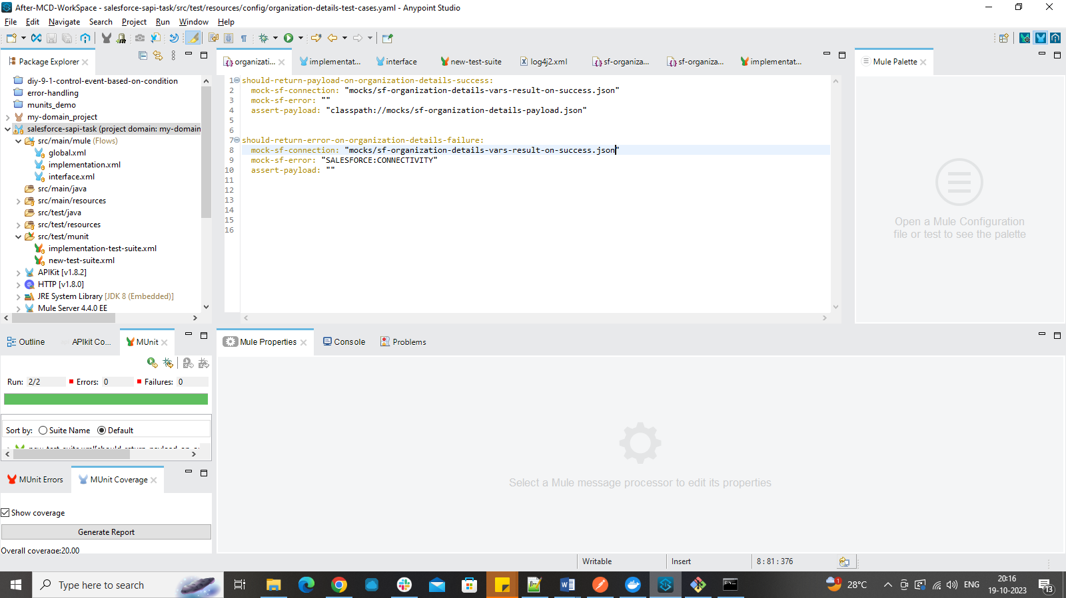

We will pass the expected payload in the json file mentioned in the test cases file.

After both scenarios are successful, all components will be getting green tick mark and we can see the coverage report as well.

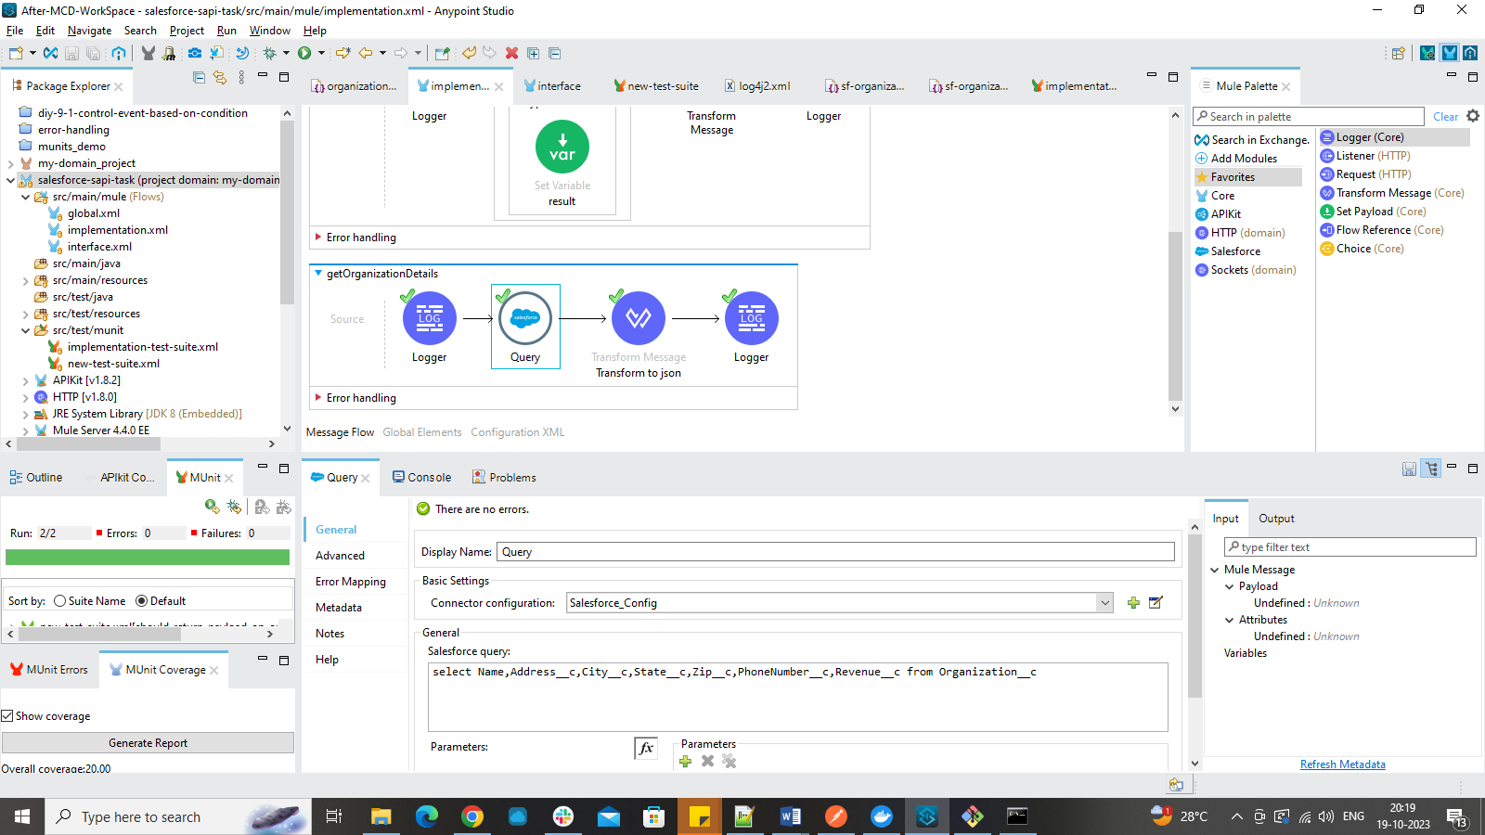

Project is pushed into github Repository.

https://github.com/RamyaDurgaCh/Salesforce-SAPI-Task

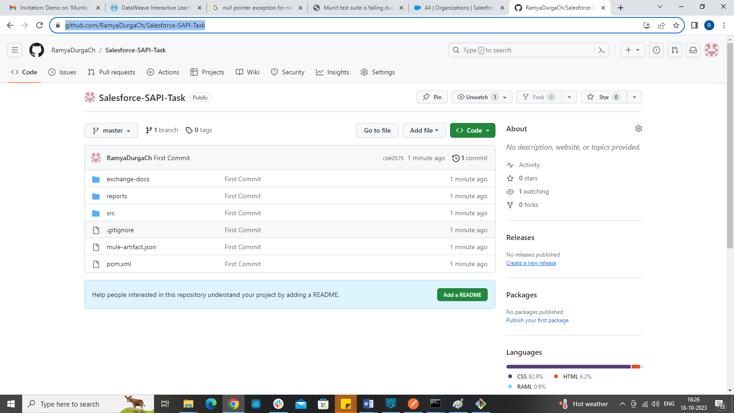

**CREATING MULE EE LOCAL RUNTIME:**

1)Download Mule Standalone from Mulesoft (Use the Link below) or search for **Mule 4.4.0 ee download** in google which will lead you to the same link.

<https://www.mulesoft.com/lp/dl/anypoint-mule-studio>

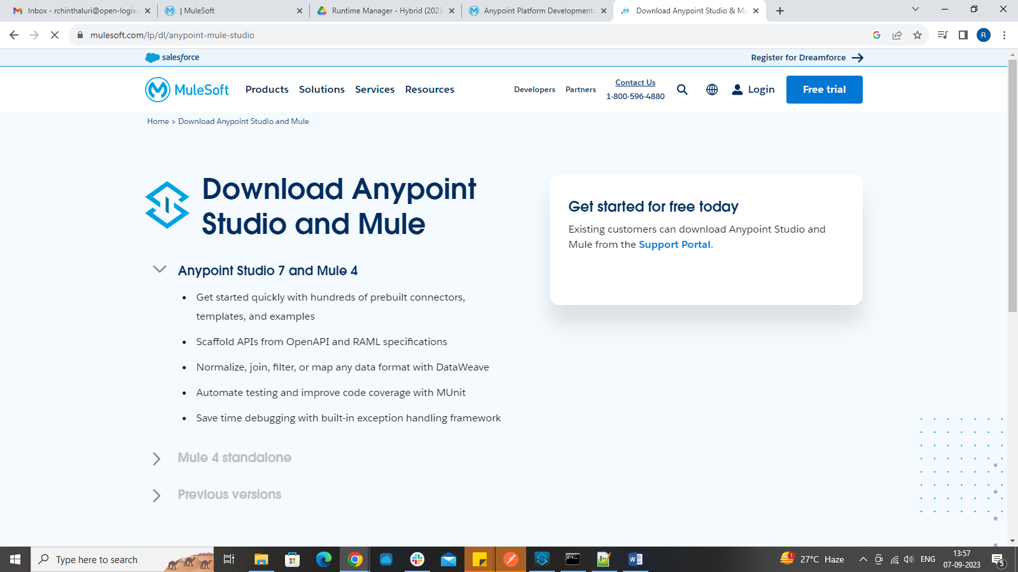

2) After providing all the details, a link will be sent to your email.

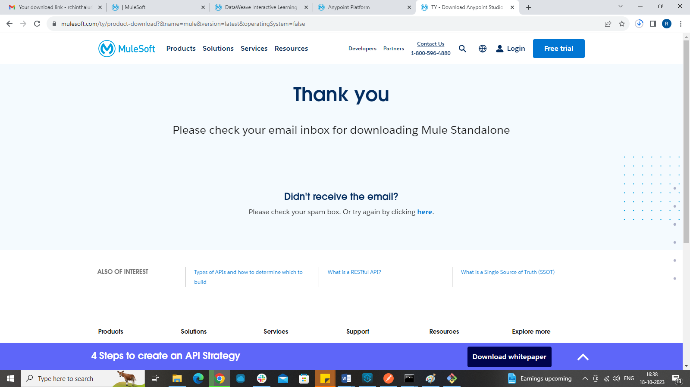

3) Download the Mule standalone runtime and unzip or extract it in the folder you want.

4)Open the folder after extracting and Go through the folders present inside the runtime.

5) Go to Anypoint platform Runtime manager.

6) Click on **Servers** option available on the left hand side of Runtime manager menu and click on add server.

7)Provide unique name for example mule-server and you will see a command and a button to copy the command.

8)Go to the folder where you have installed your mule standalone runtime and go to bin folder and open command prompt from there.

9) If you are using linux or mac OS, you can directly run the command in the path and it will install the runtime and in runtime manager you can see the server gets added up.

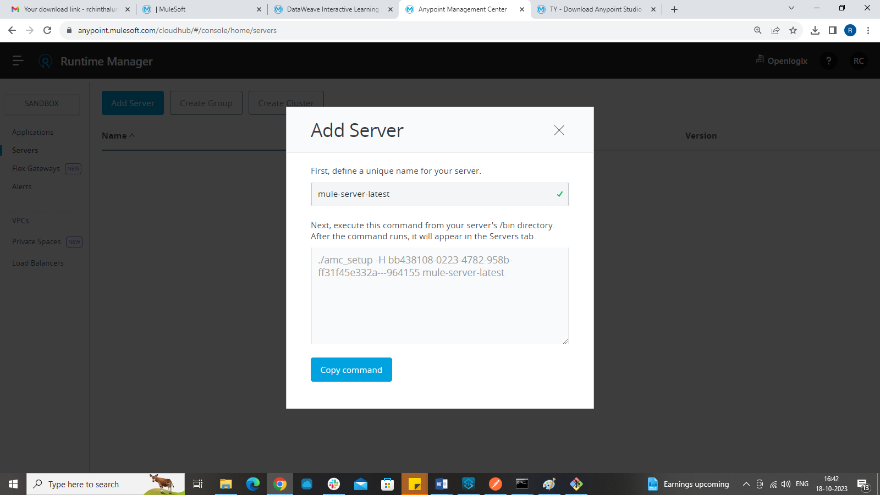

If you are using windows OS, remove “**./”** before the command and run the command. It will give the same result and server will be created in Runtime manager.

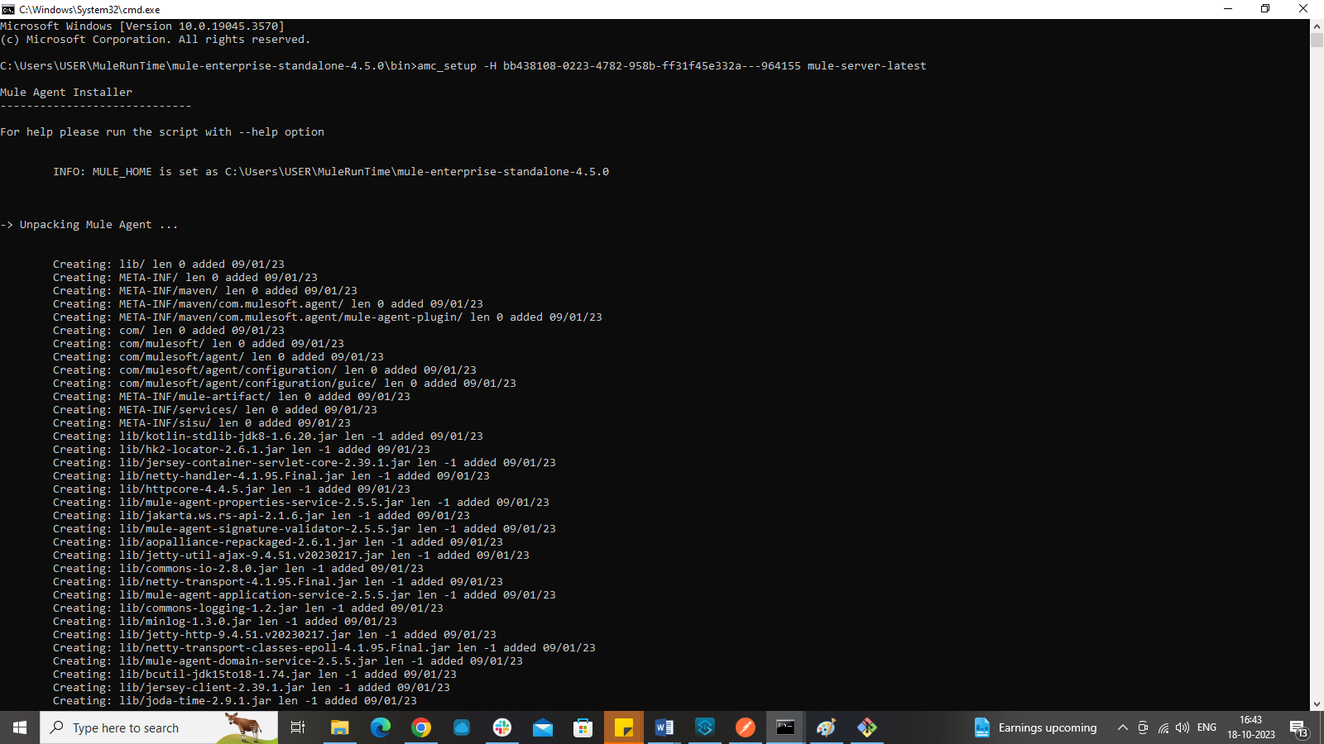

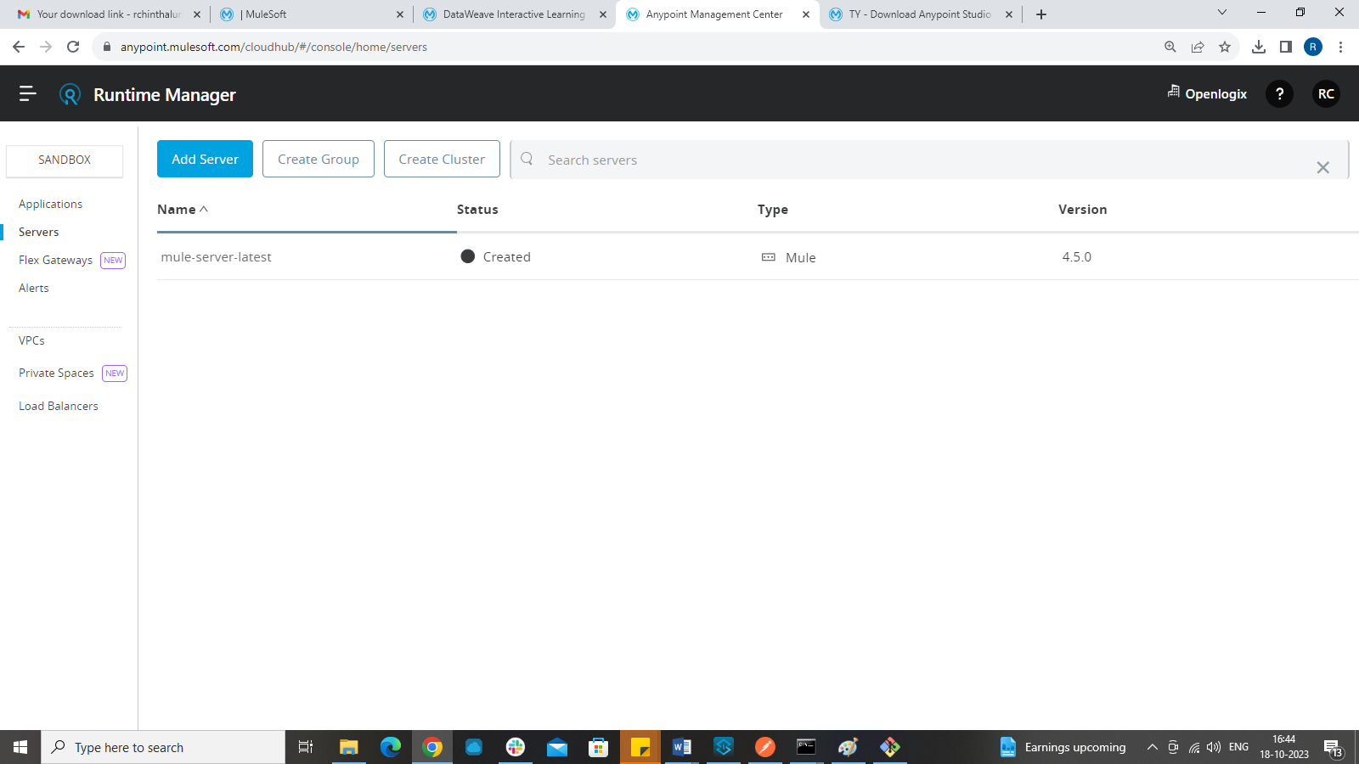

10)To run the mule runtime, we need to go to command prompt again and give the command as

Mule

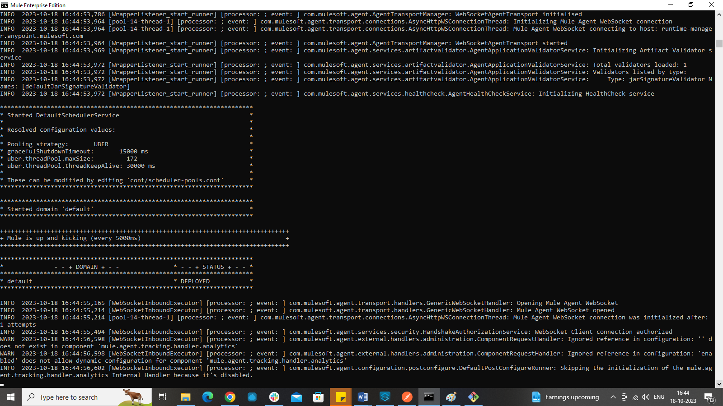

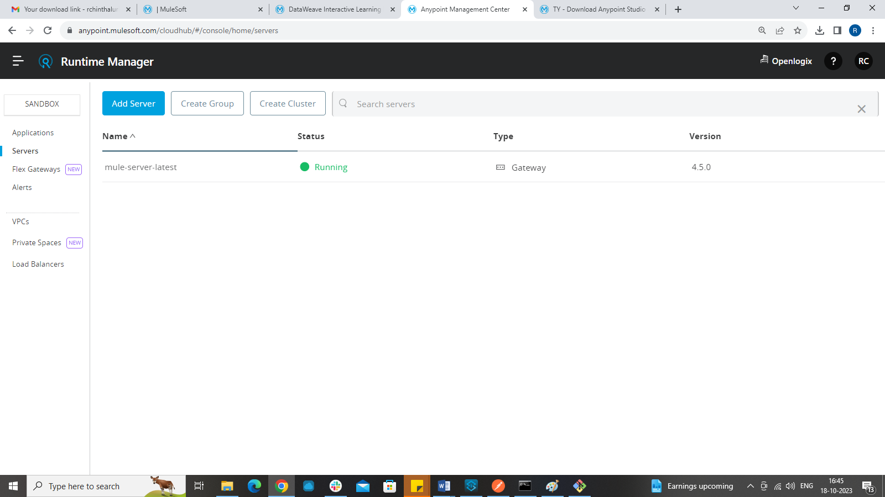

CREATING DOMAIN PROJECT:

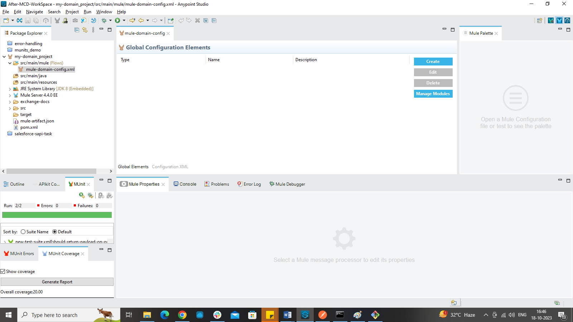

Add modules:

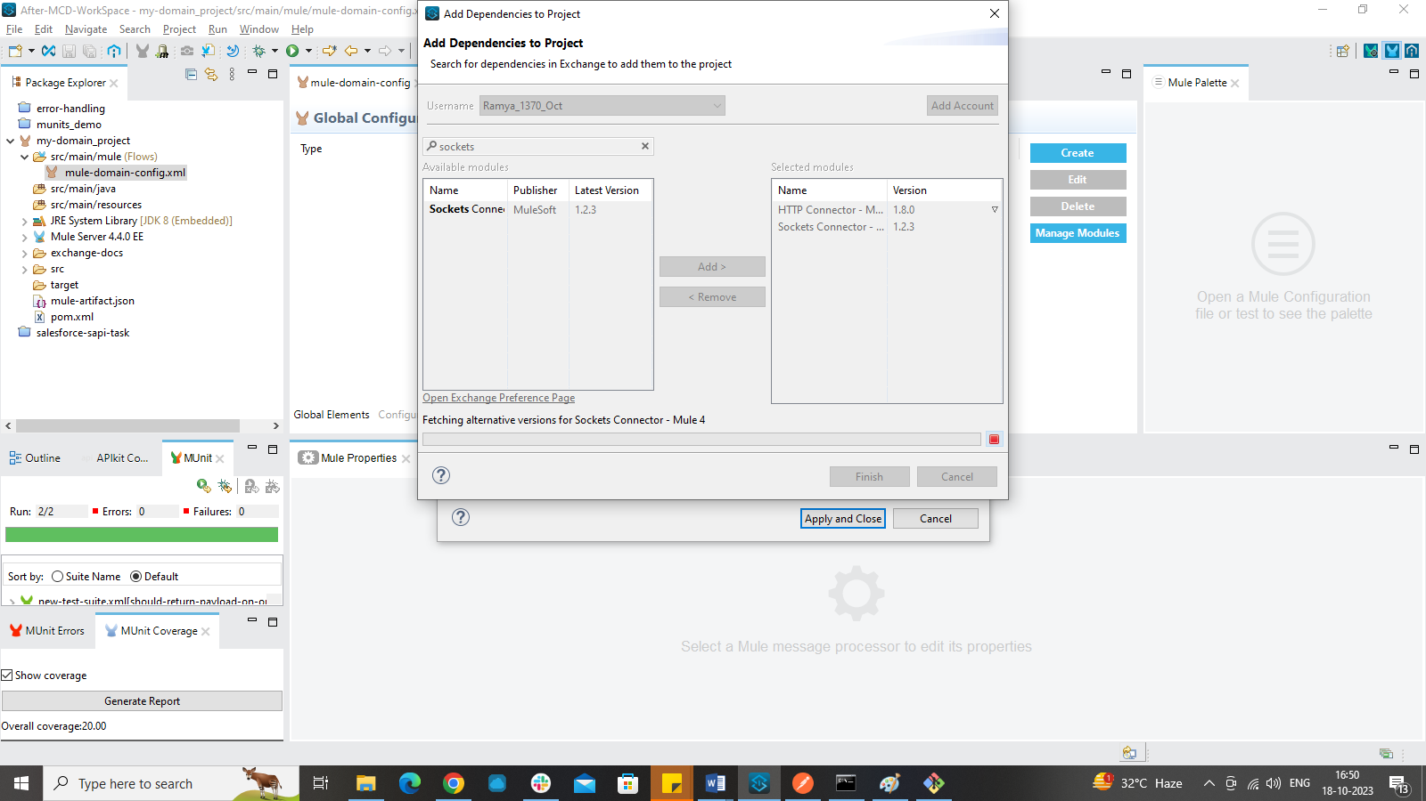

Port is set as 8082

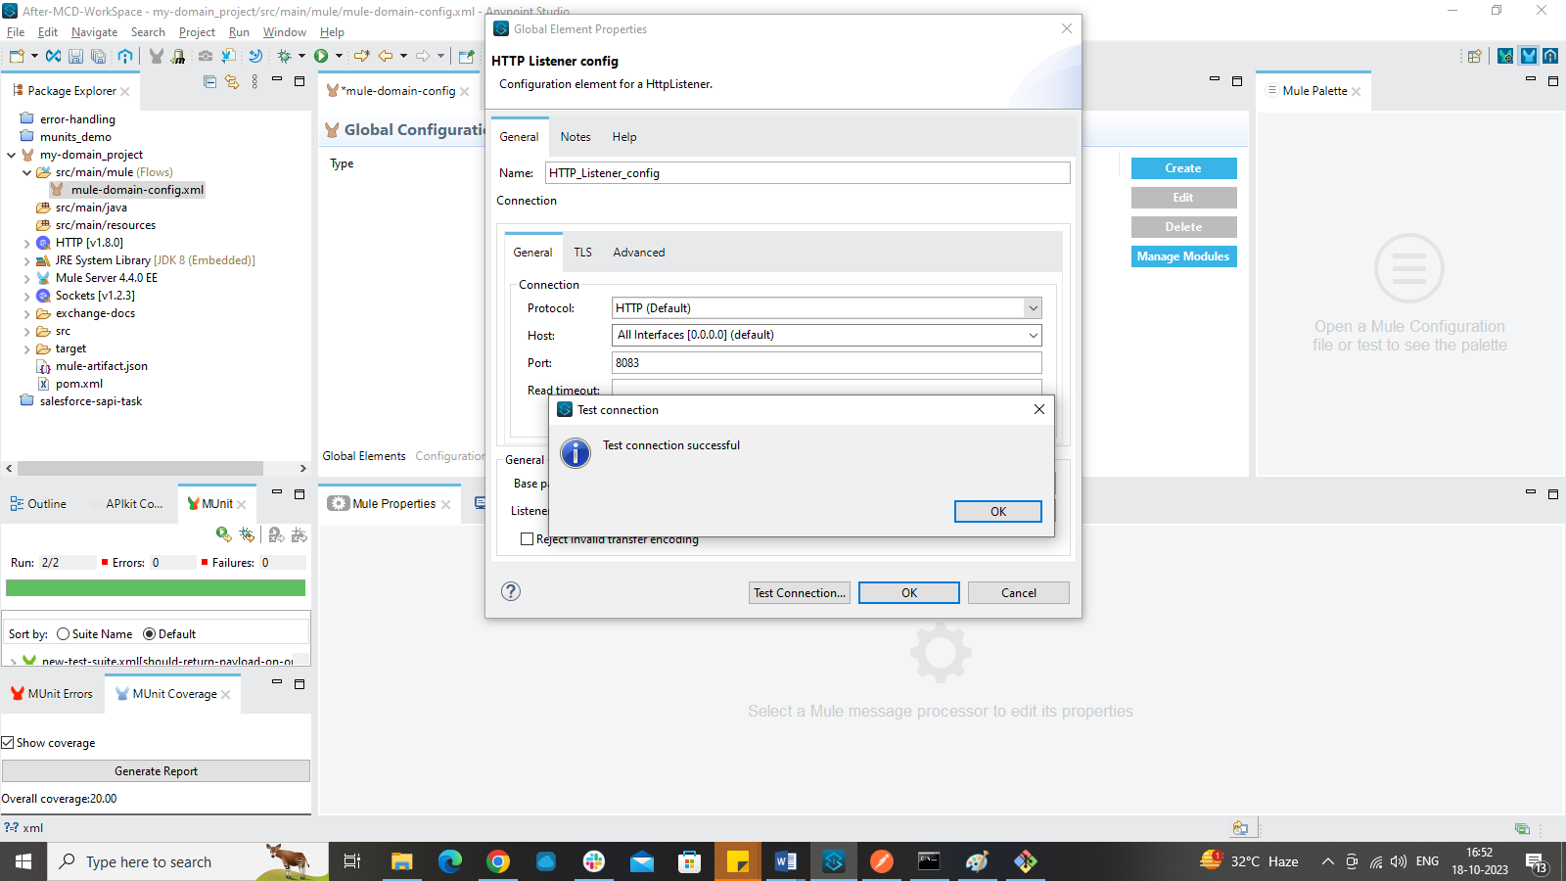

Changing the domain of your salesforce-sapi project:

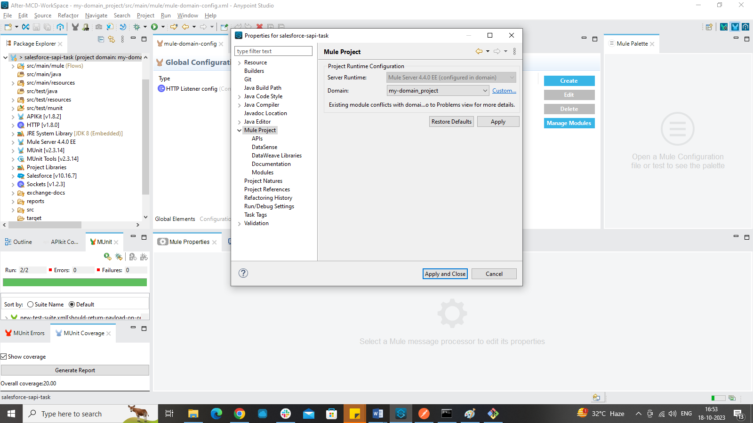

Output after changing listener config to domain listener config:

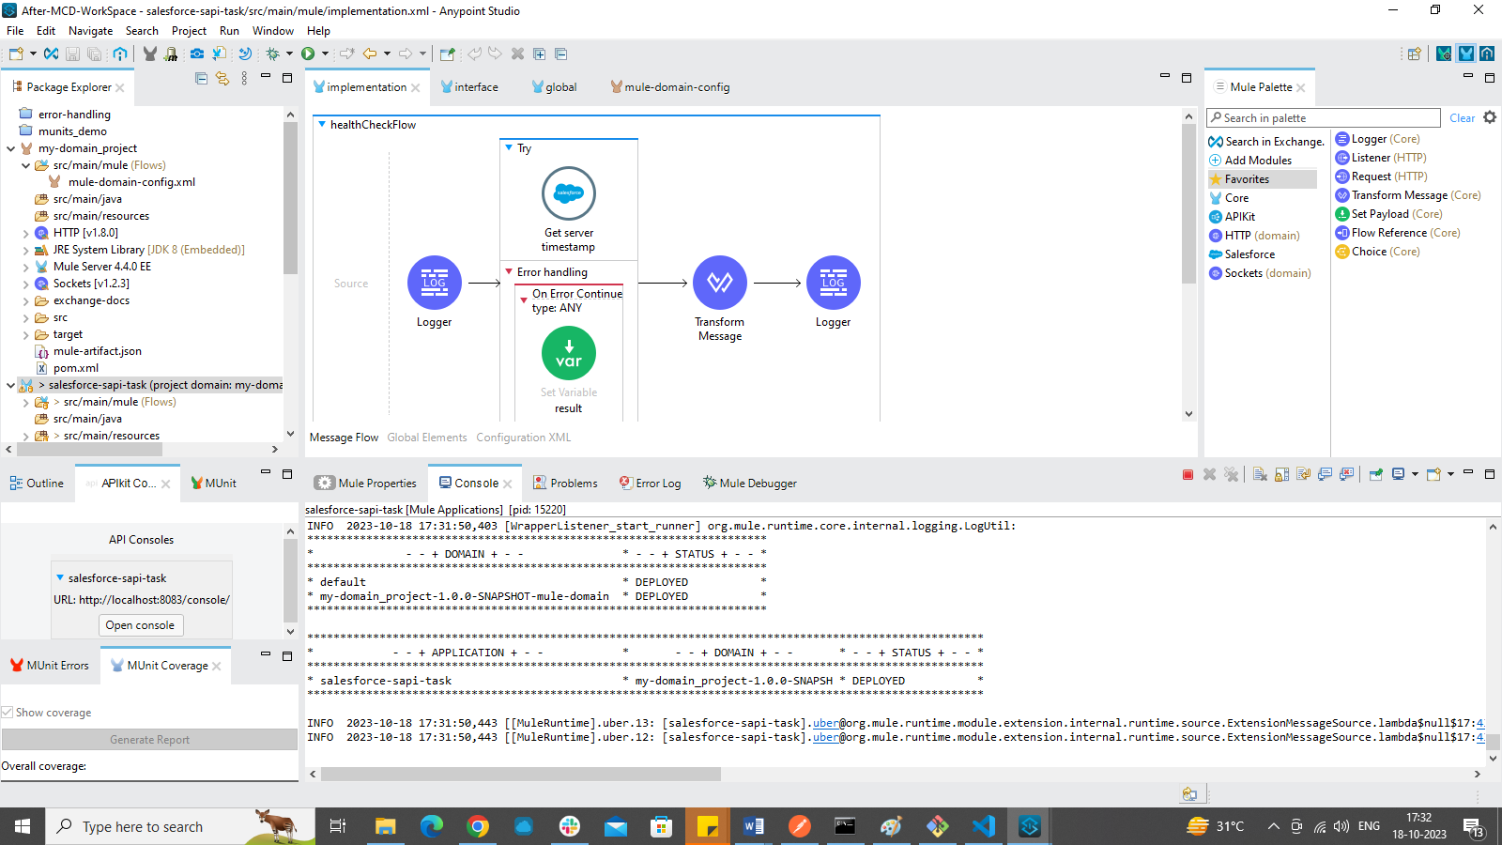

OUTPUT:

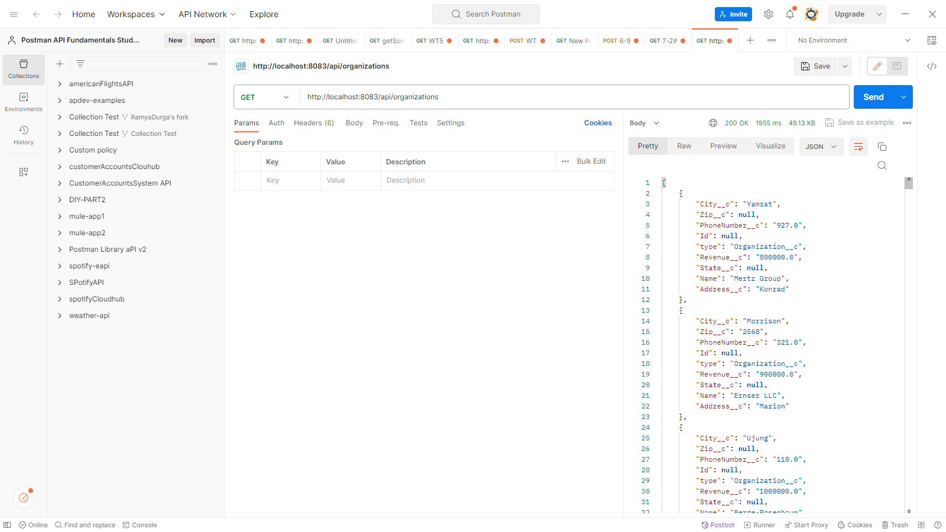

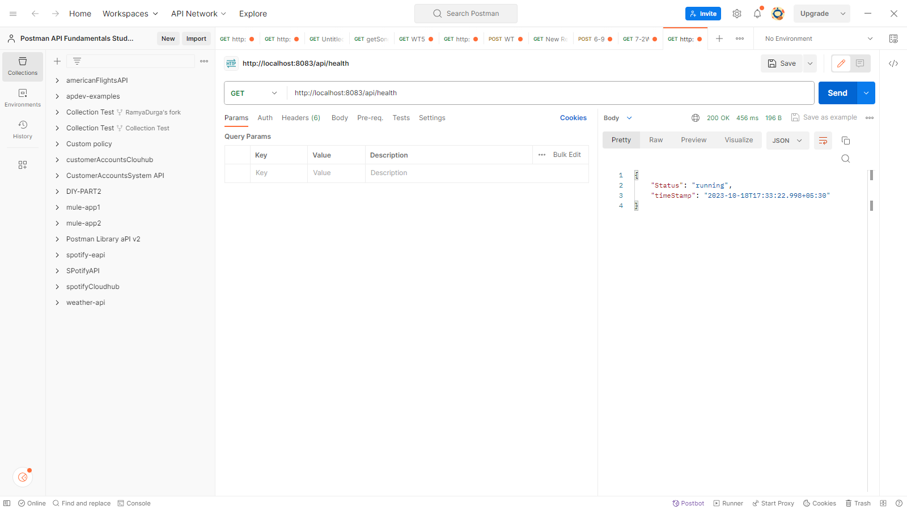

CREATING A JAR FILE:

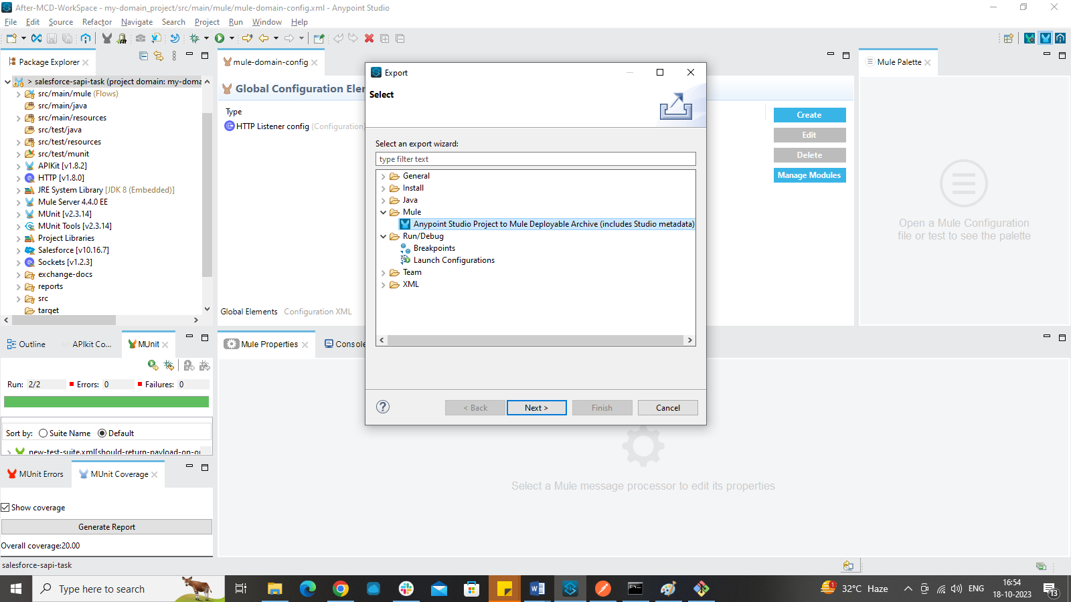

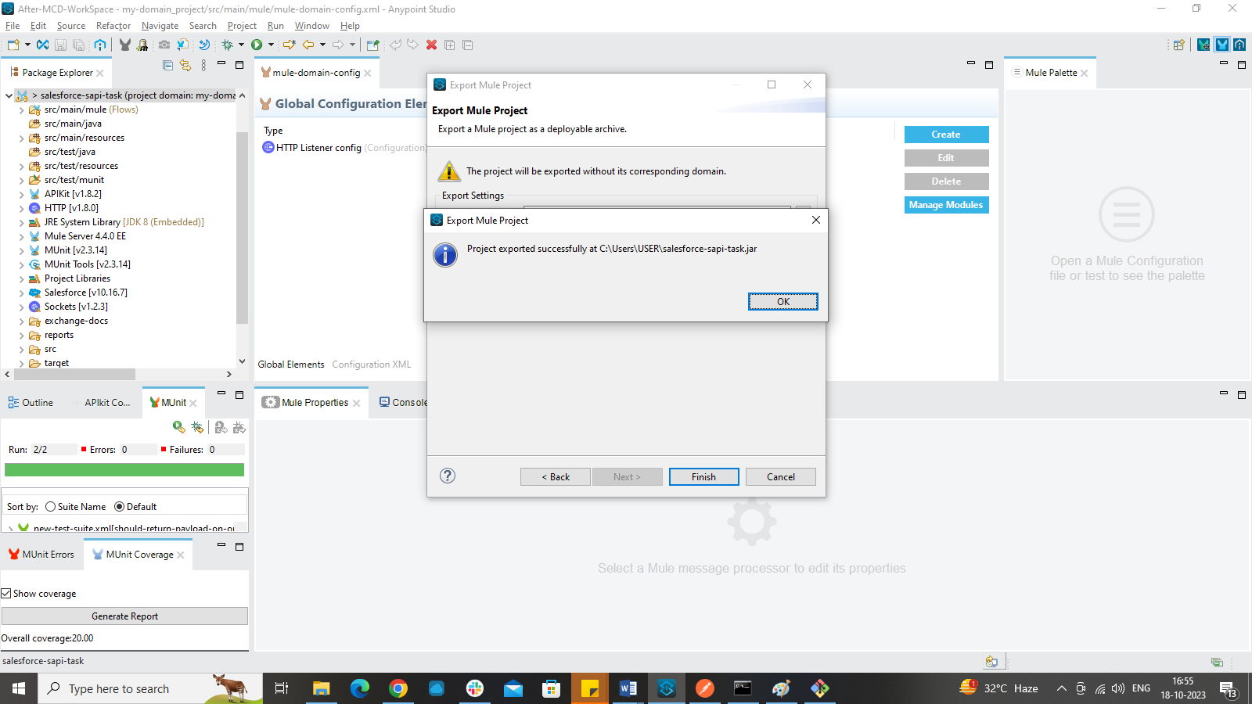

We create the jar files of our domain project and our salesforce-sapi project and deploy them using hybrid deployment.

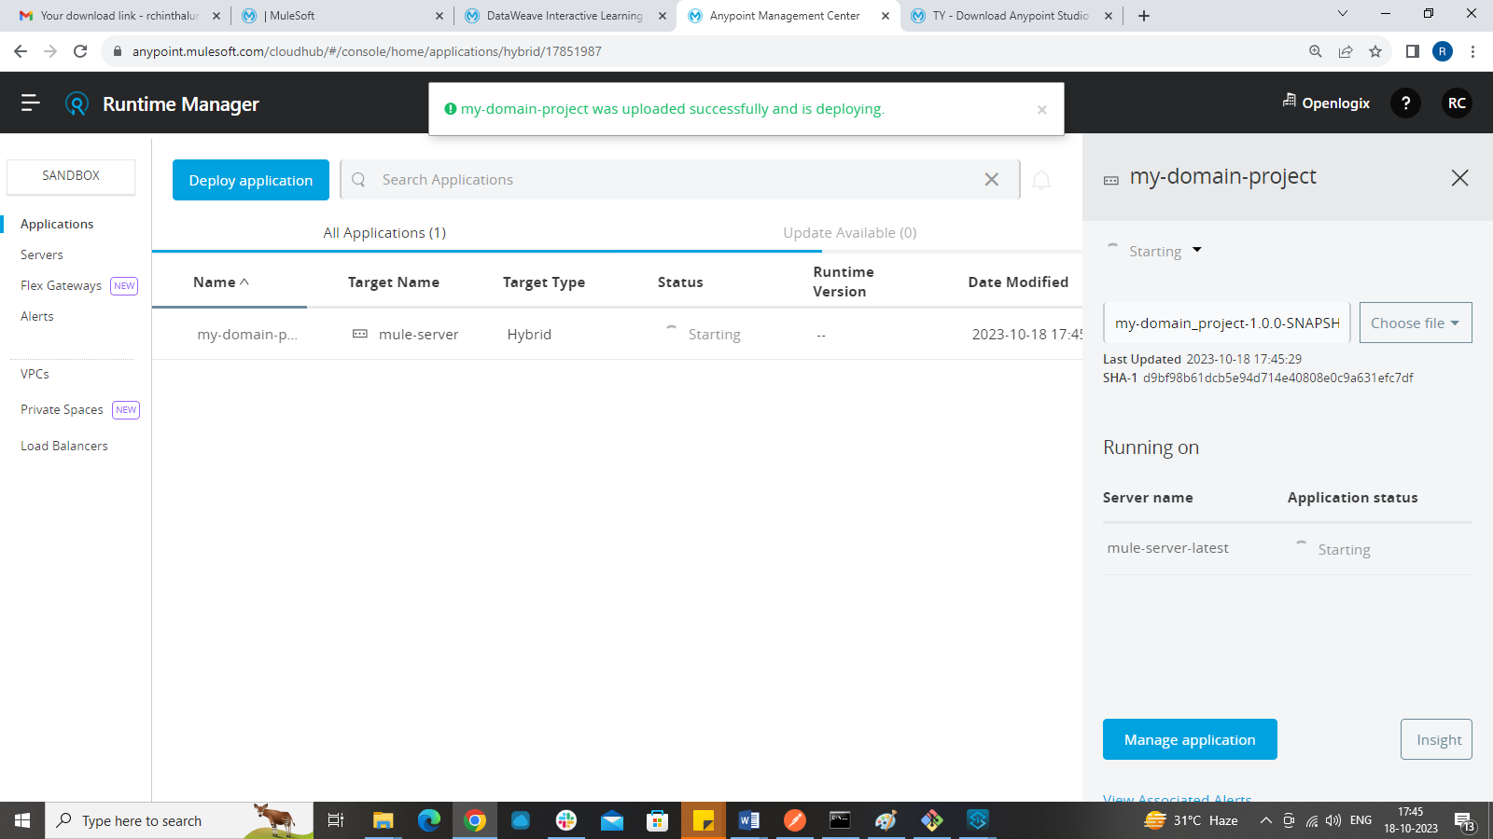

Error:

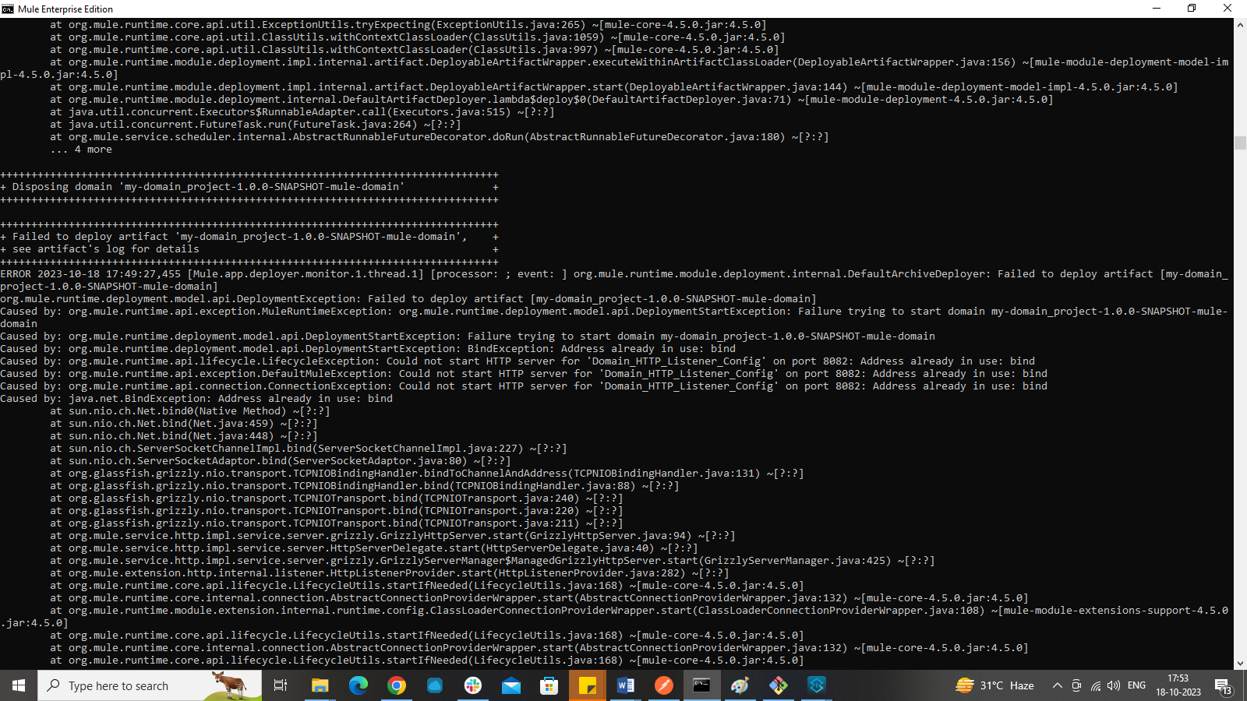

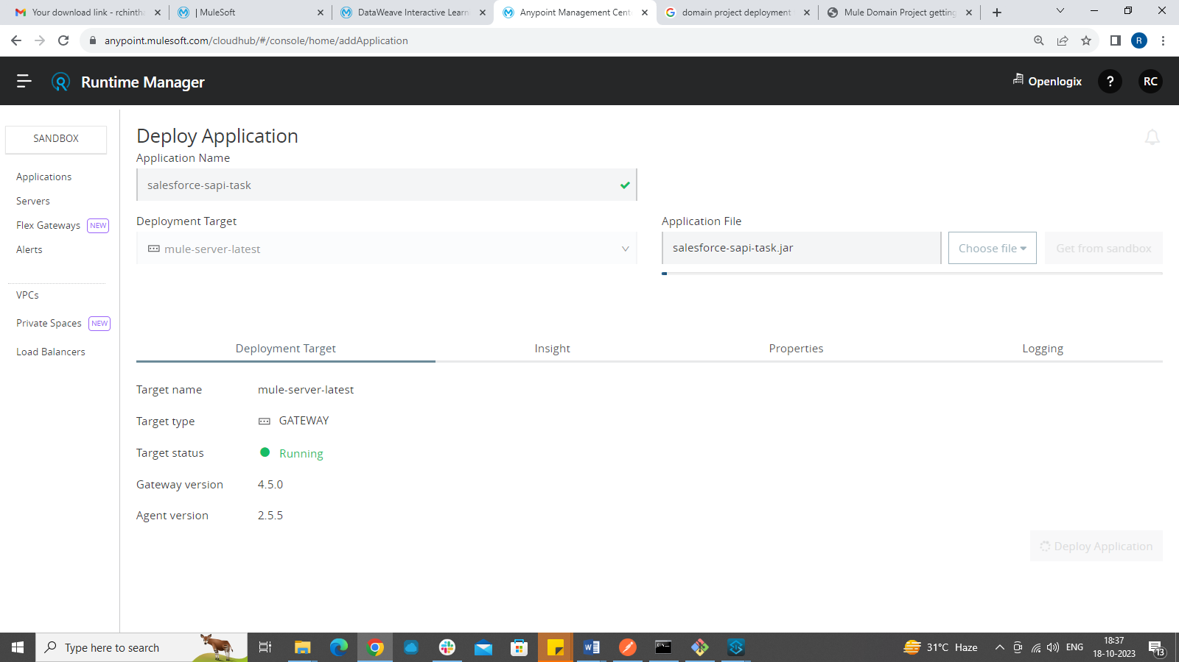

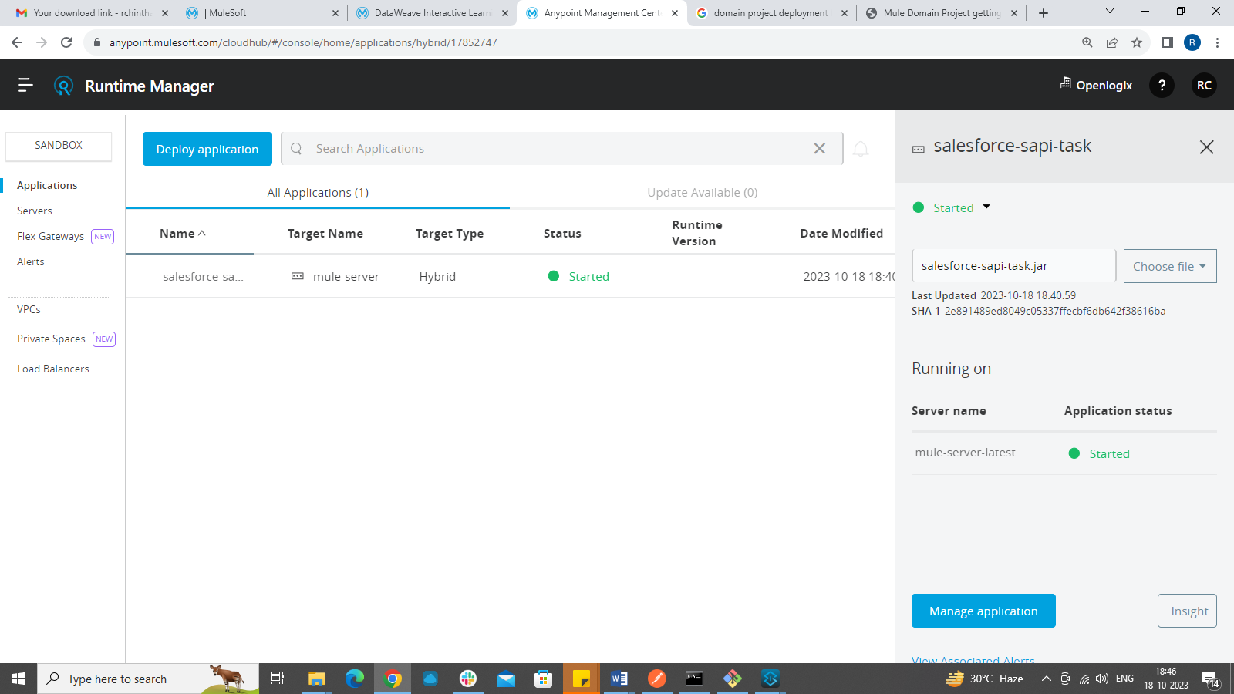

OUTPUT after deployment:

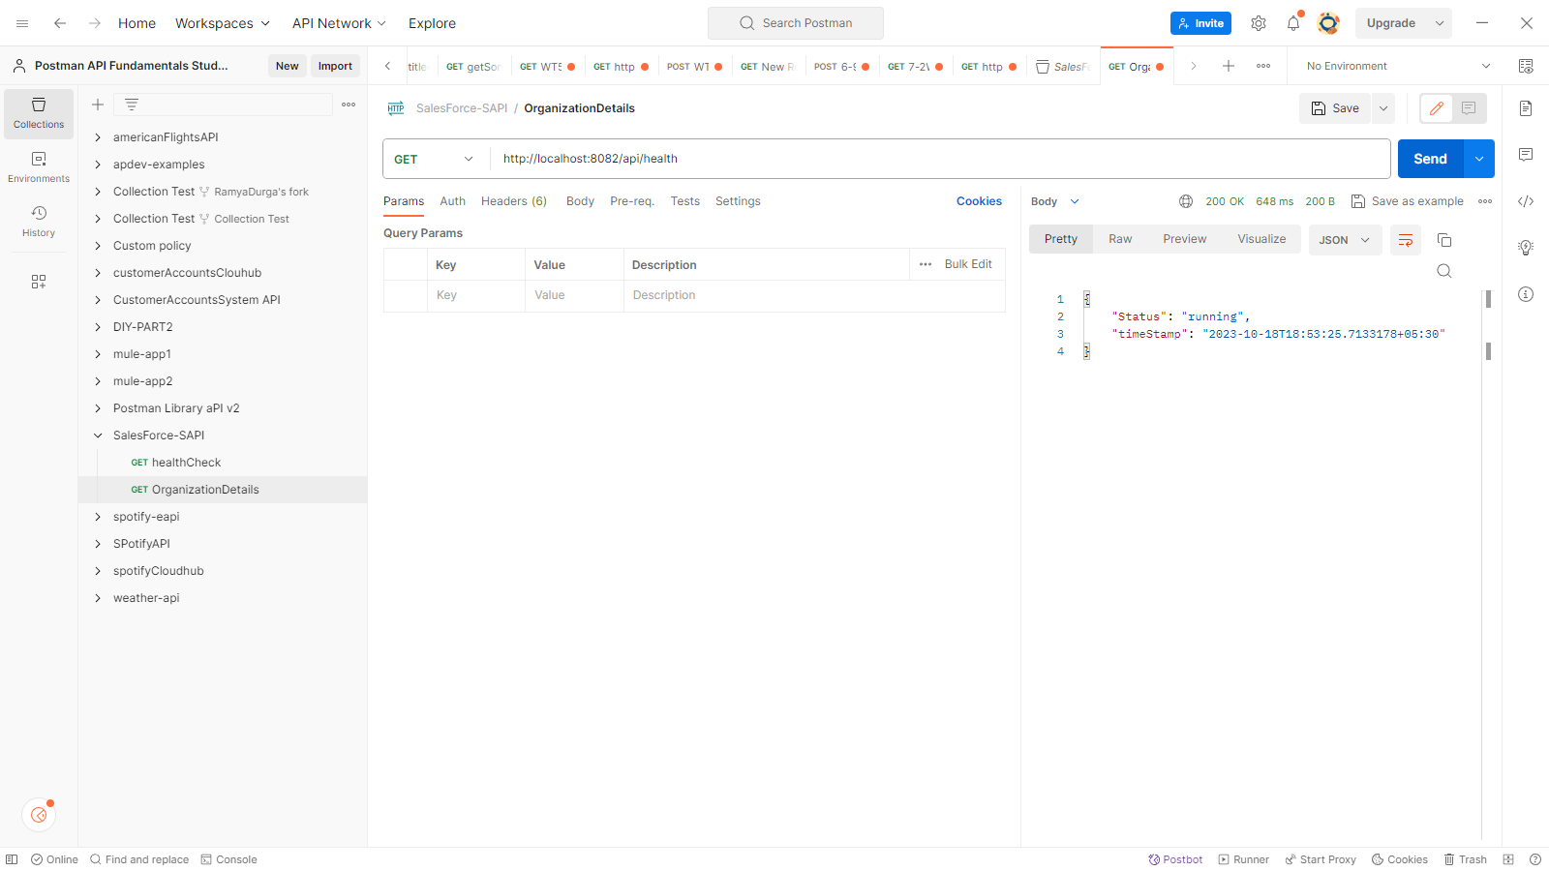

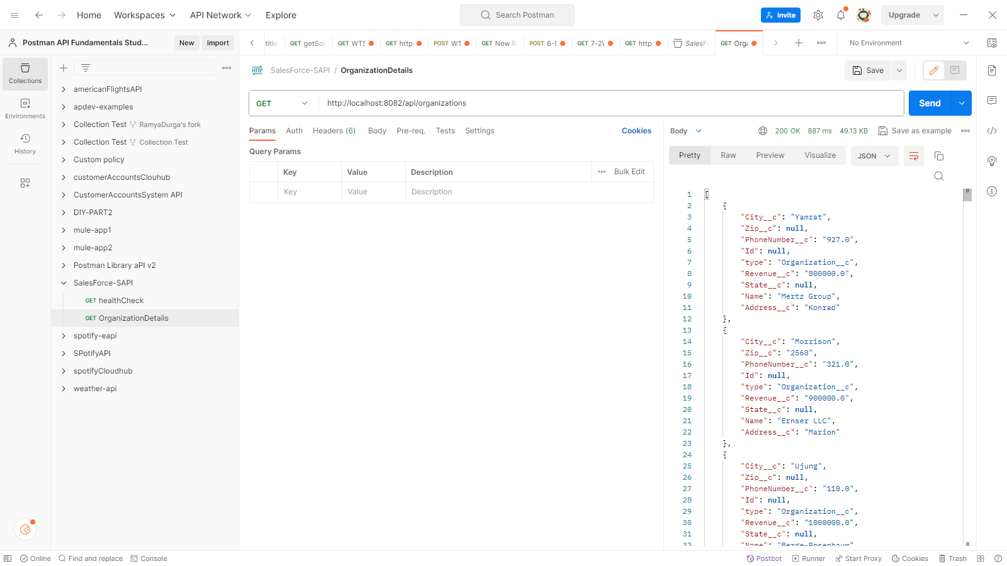

APPLYING CLIENT ID ENFORCEMENT:

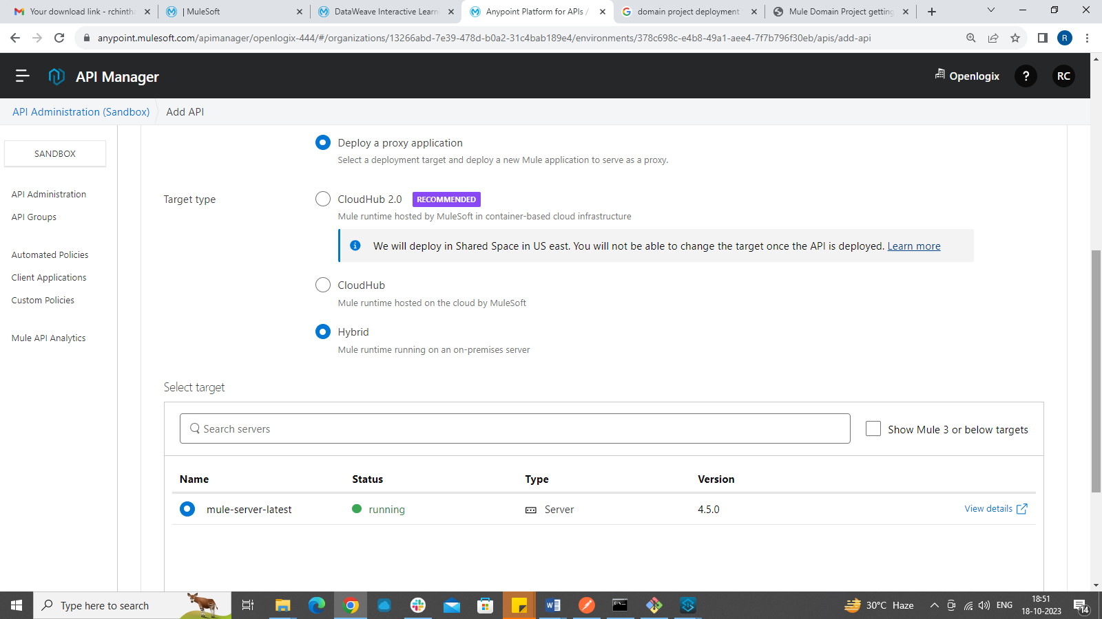

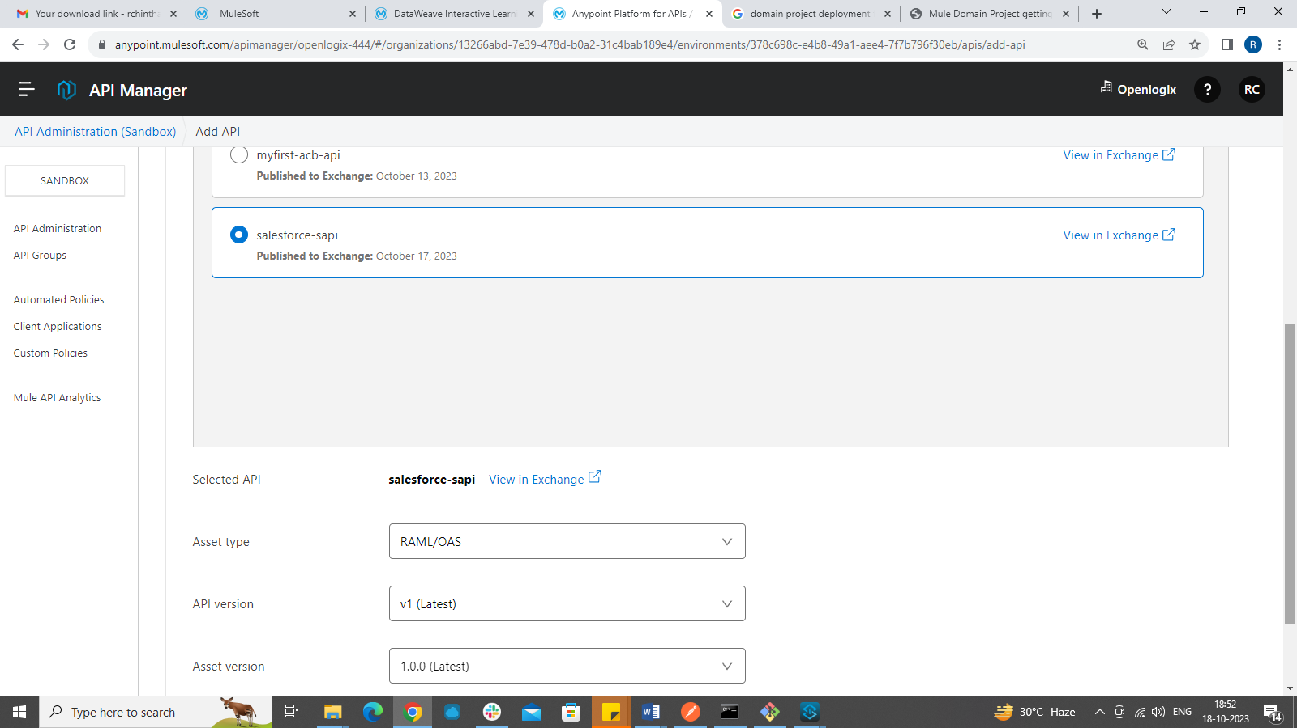

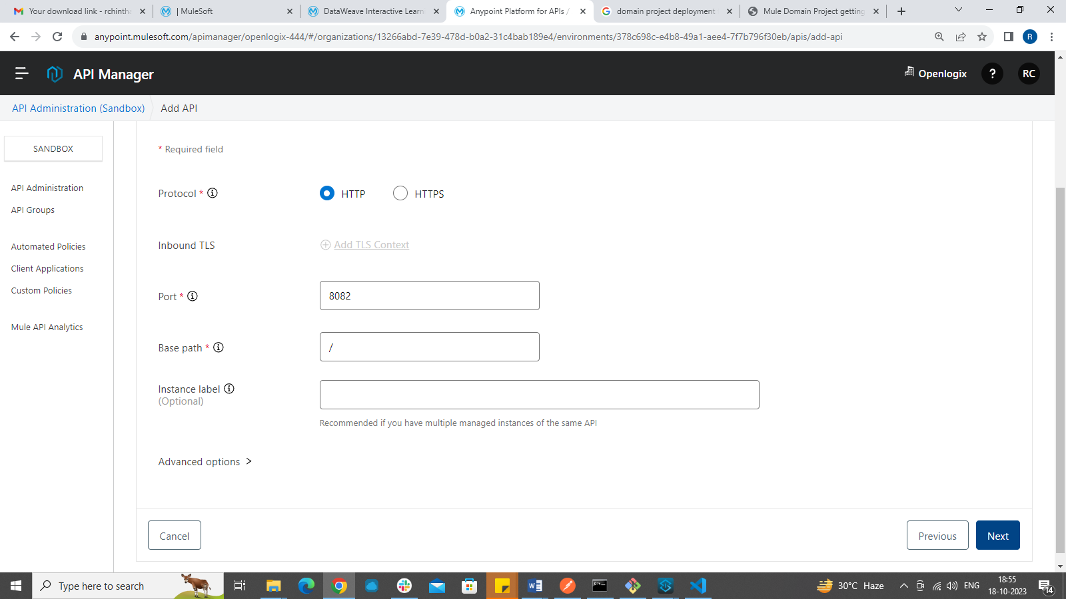

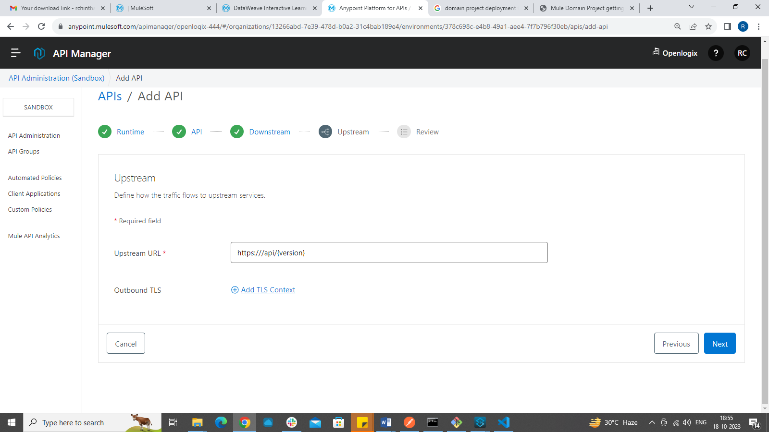

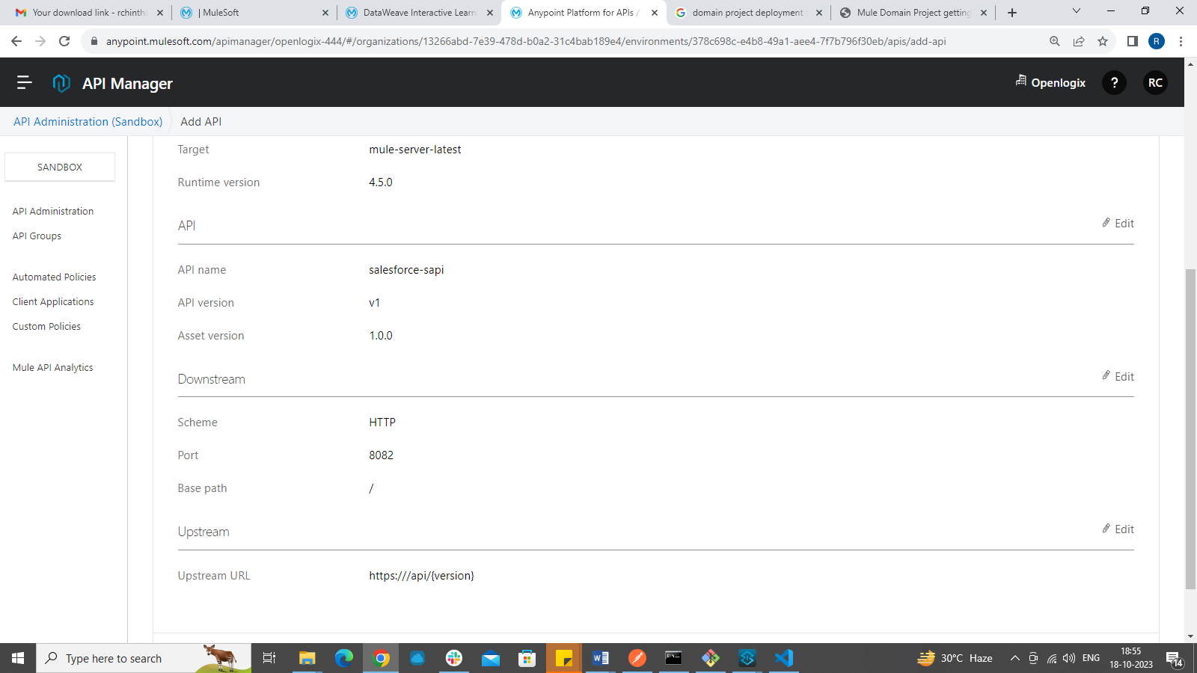

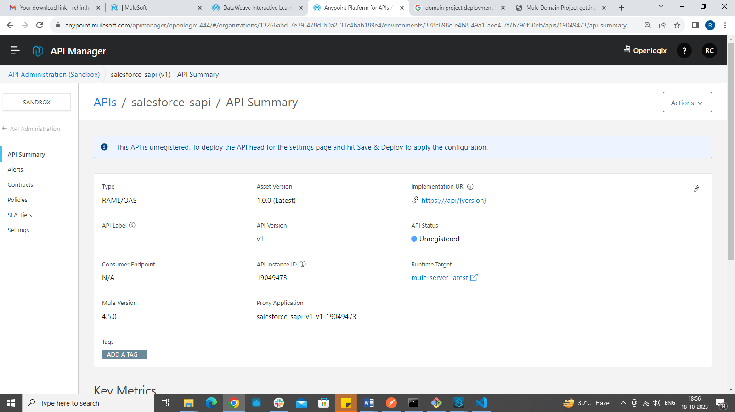

CLIENT ID ENFORCEMENT:

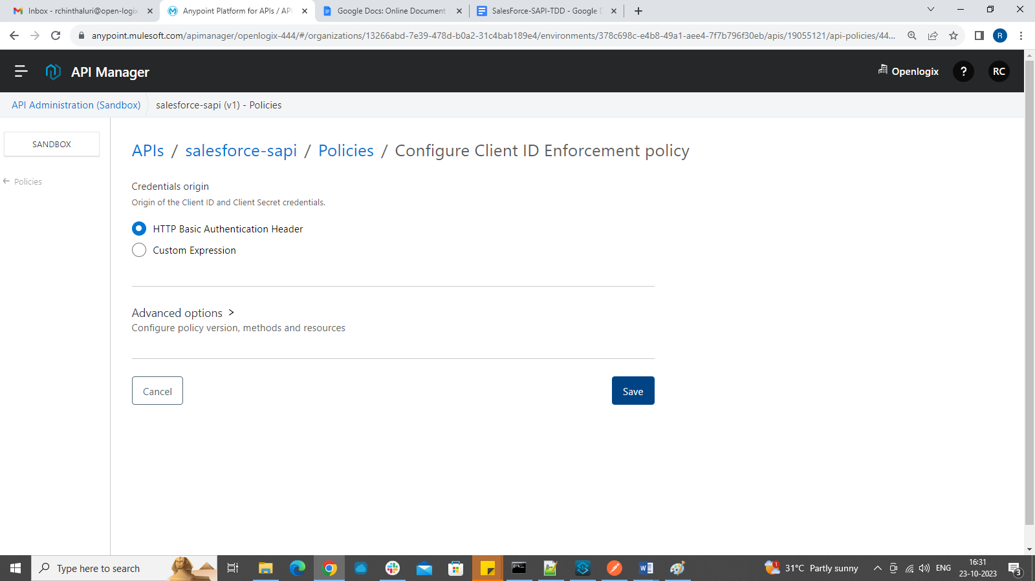

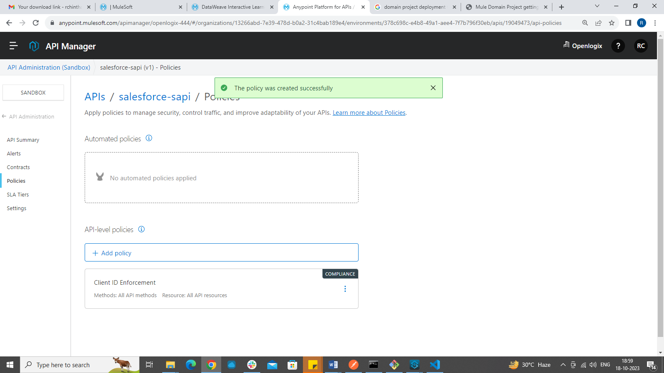

Output after applying Policy:

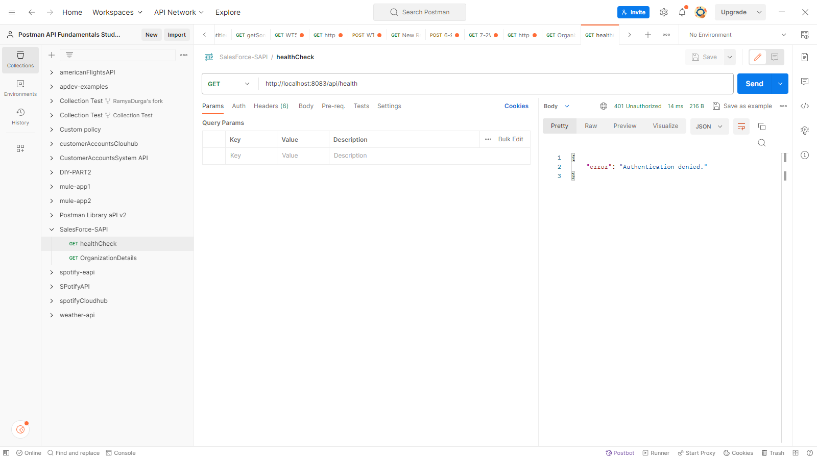

After providing authentication- output:

To get the access to your API implementation, we must send client id and client secret along with each request.

To get the client id and client secret we need to go to exchange ->click in the API spec -> click on Request access. Select the Api instance and application.

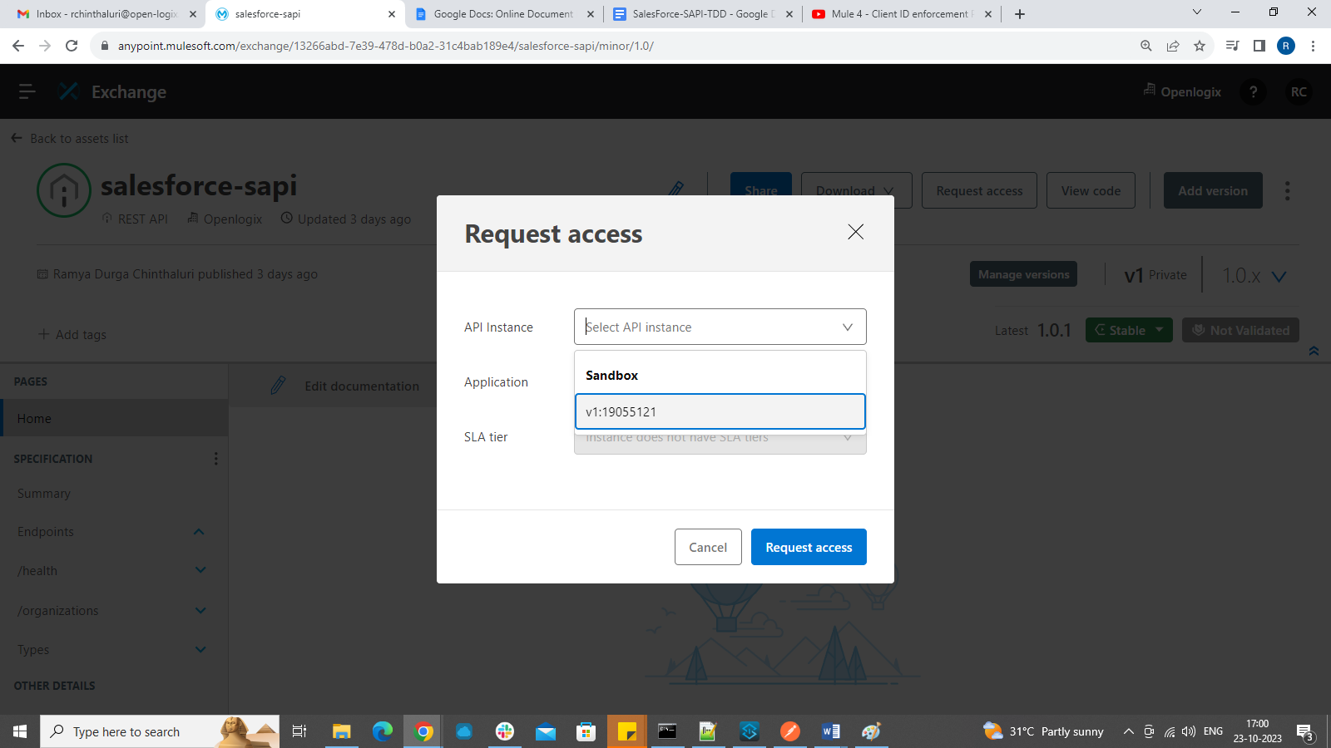

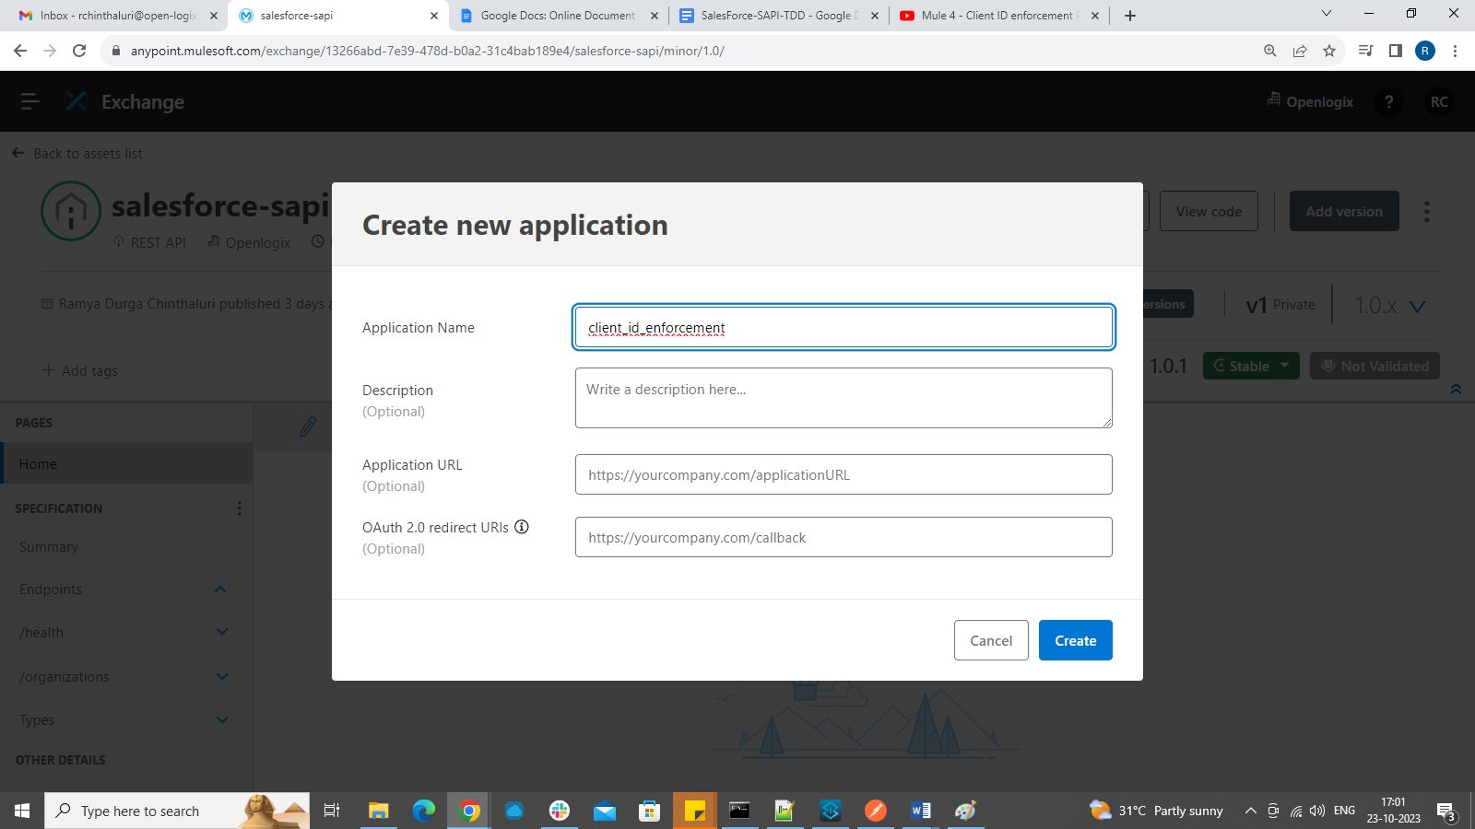

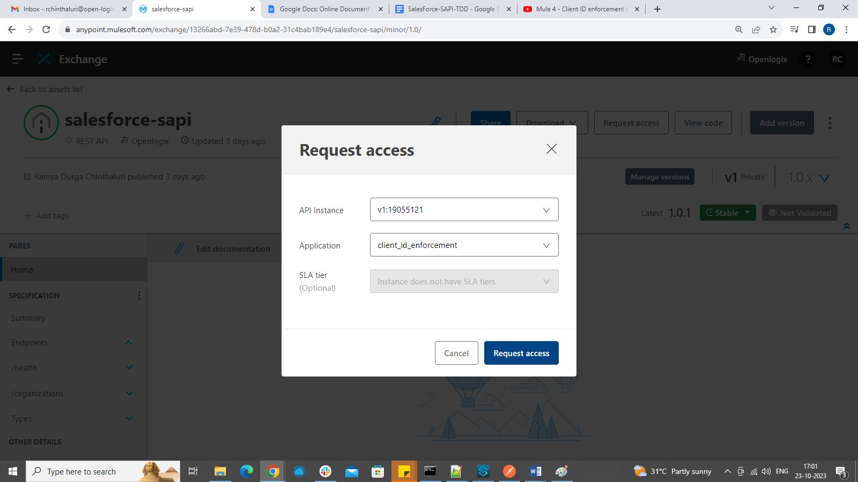

clientID:

3734d4fe035549b4a4543b80f1816ac9

Client secret:

76F88023d3Ee43C8a83eCC7E24A357cb

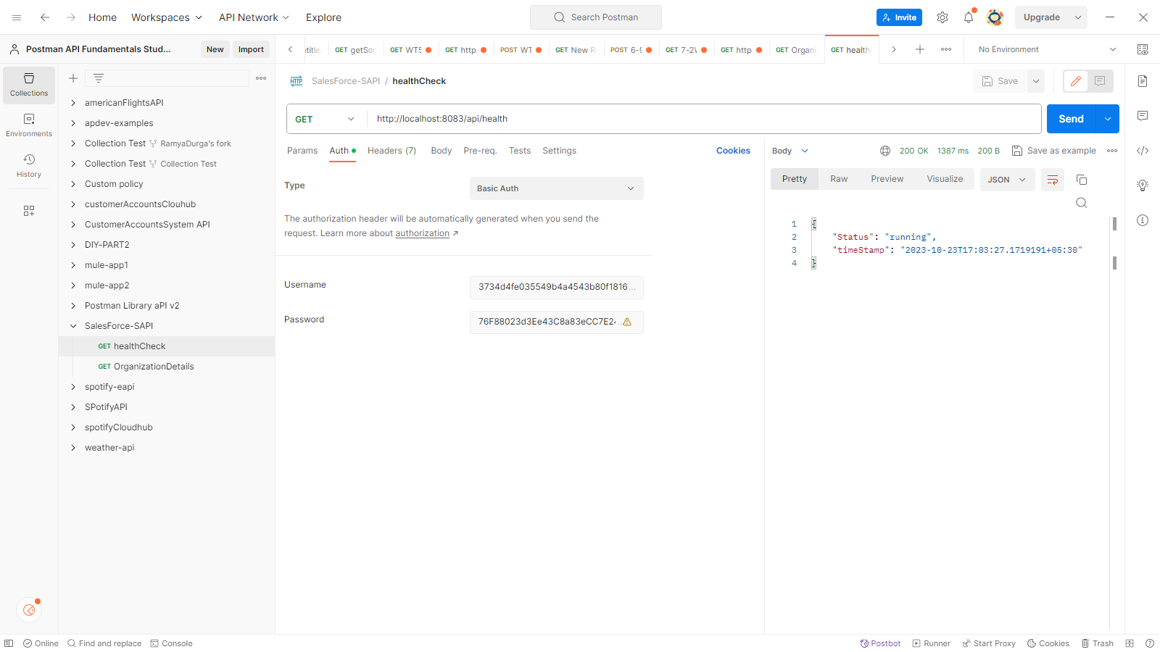

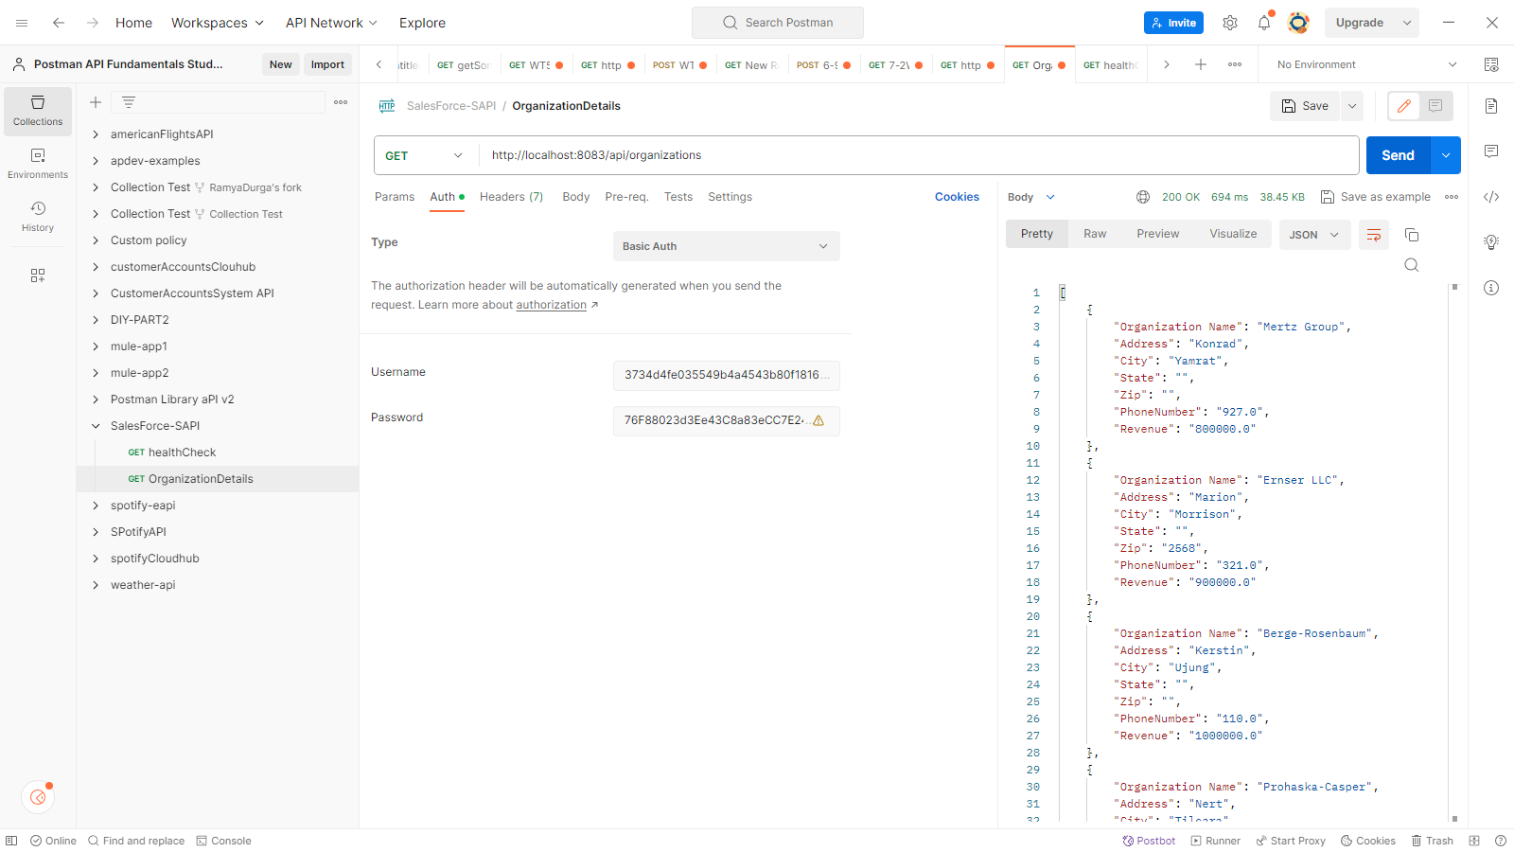

USING SPLUNK FOR LOG MAMAEMENT:

If we are using Splunk for the first time, we need to install the image of splunk from docker hub and set the ports that you require to connect.  
I already had an instance of docker with ports configured , So I just started the Splunk Container that is already installed.

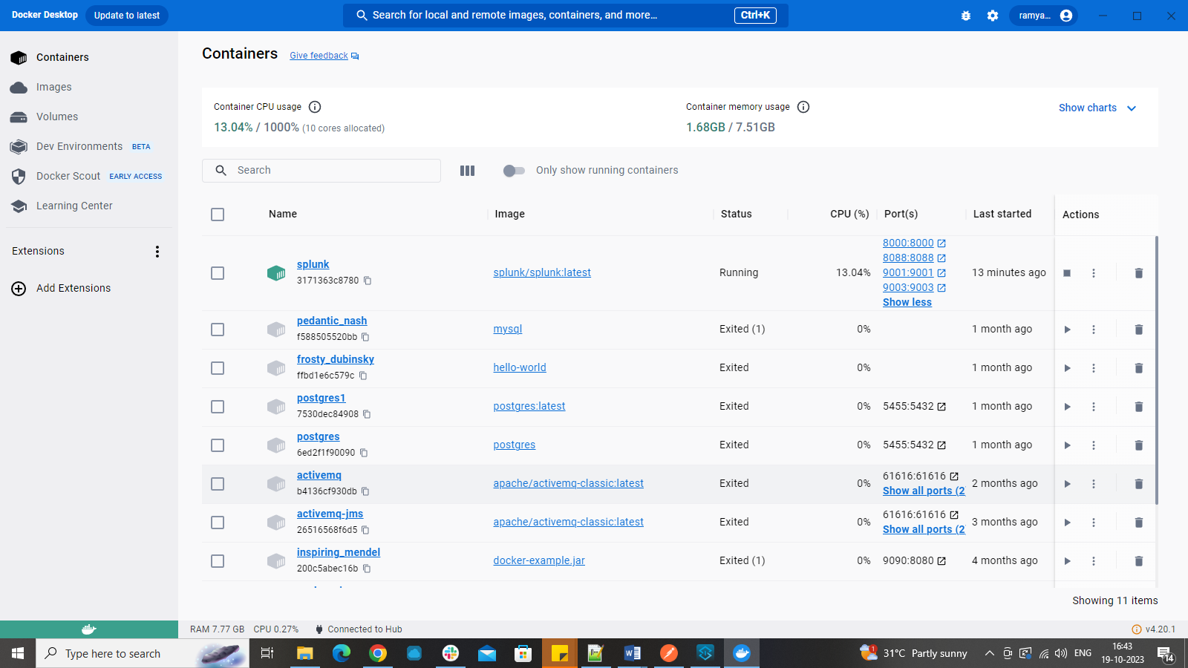

When Splunk Container starts Running, You can open its web console using below URL:

<http://localhost:8000>

**CREATING TCP port:**

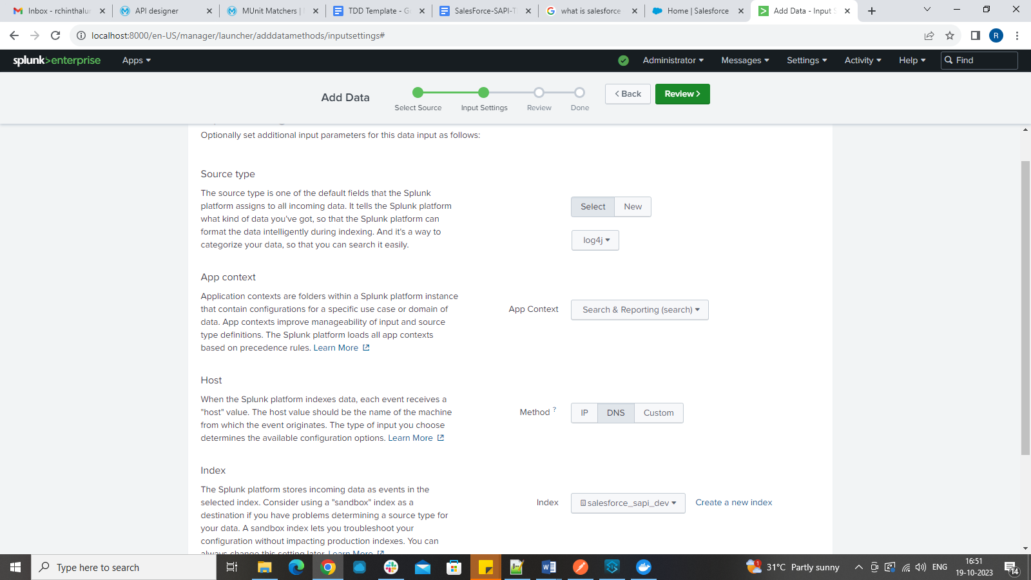

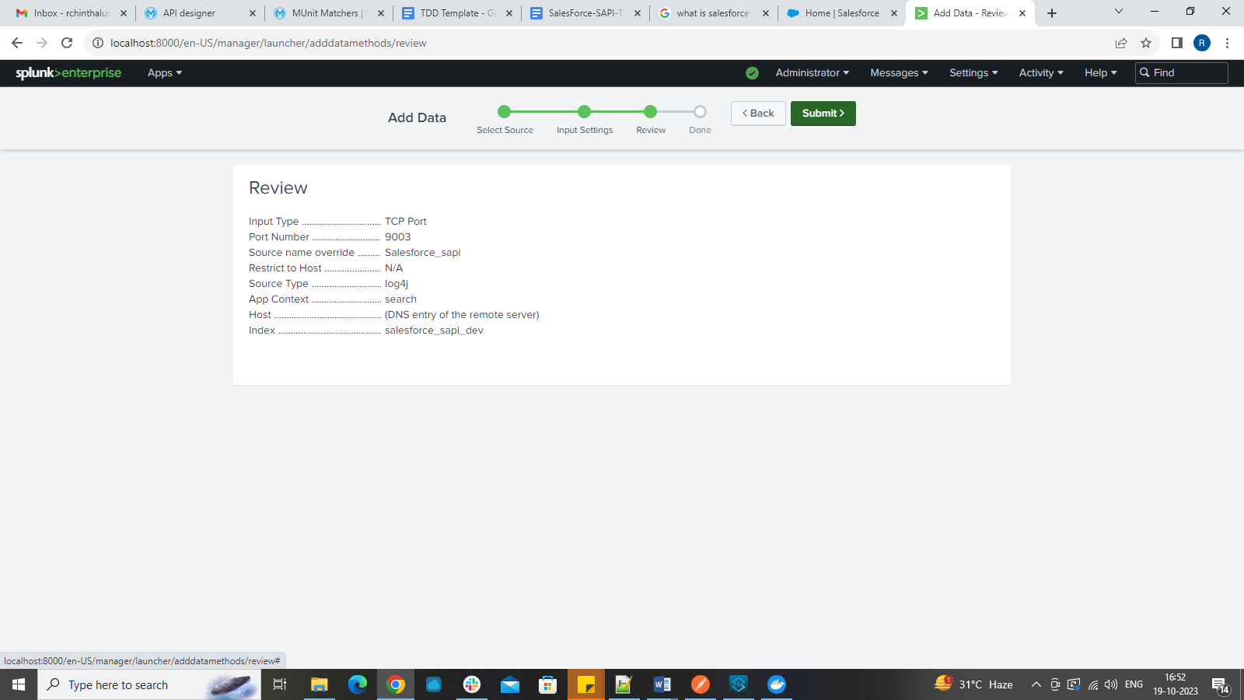

Adding configuration of tcp port in log4j2.xml:

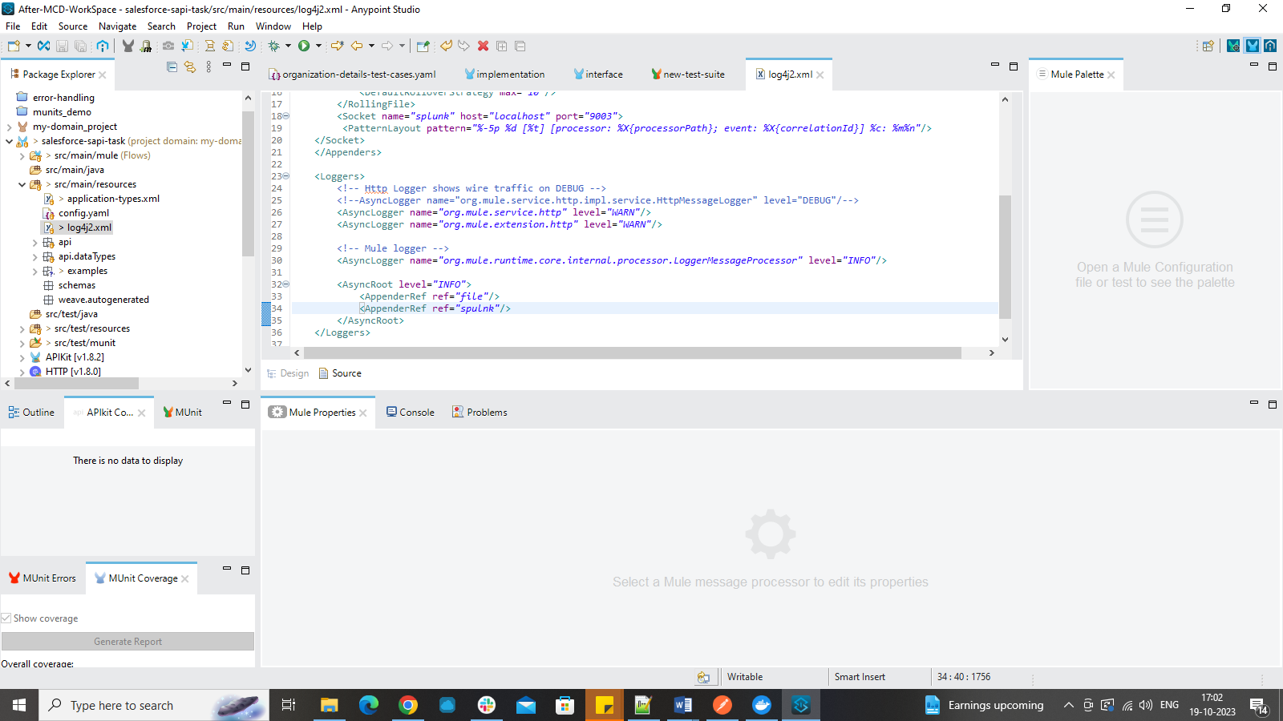

When you redirect your logs, you can see logs in the Splunk.  
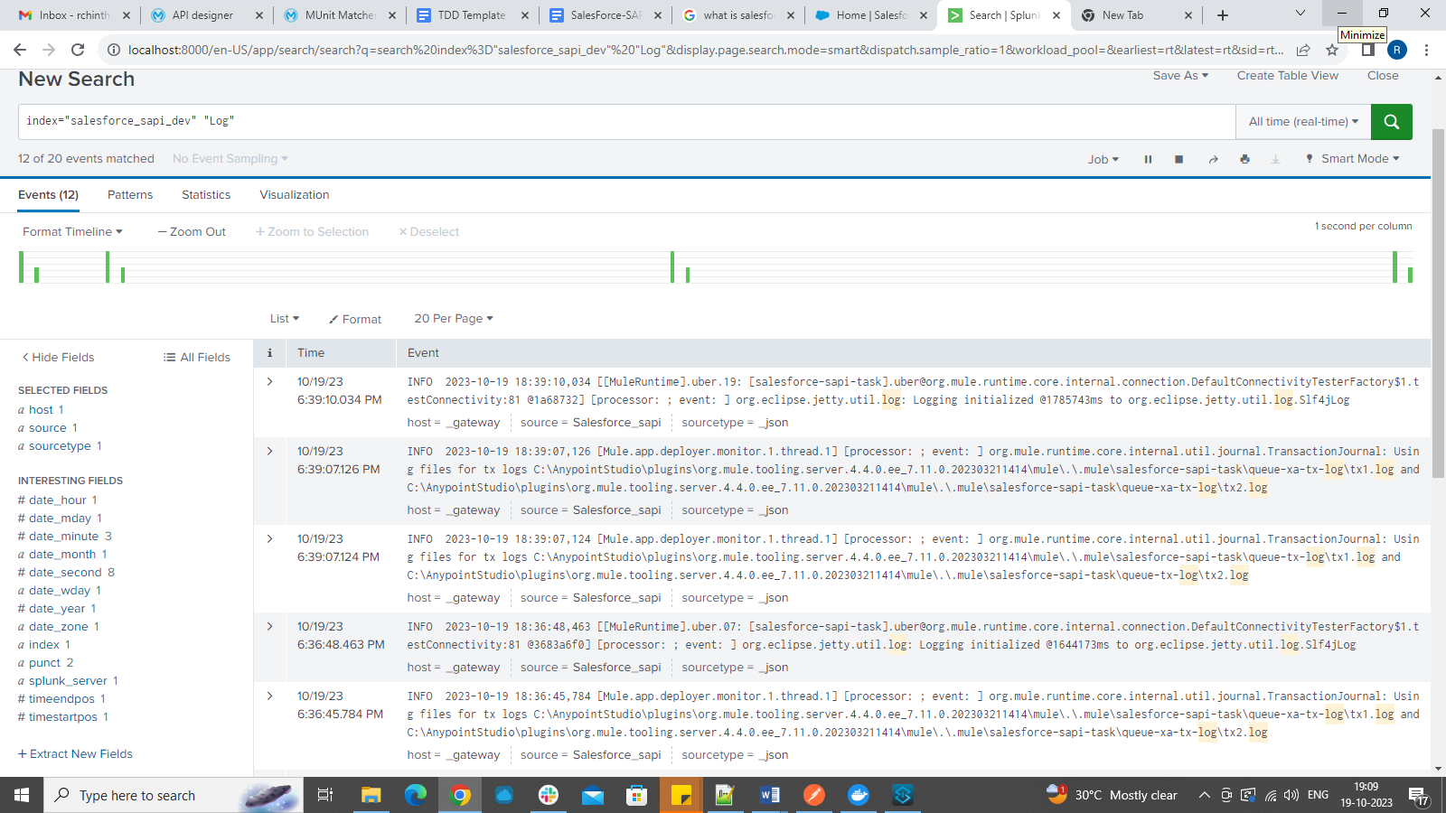

**POSTMAN COLLECTION:**

